**The horizontal surface** configuration of the Earth's lithosphere refers to:

* **the distribution of individual landmasses on Earth,**
* **the course of the coastline.**

**THE DISTRIBUTION OF LAND ON EARTH**

The contemporary distribution of landmasses, as well as oceans on the Earth, is the result of the Earth's long and geologically rich history of events

**THE COURSE OF THE COASTLINE**

**The coastline**, not to be confused with the **shoreline**, is defined as the natural boundary between land and water (at mean water level). Varied by numerous factors, **the course of the coastline** allows for the identification of parts **known as coastal features**. These include:

* on the **land** side: islands, archipelagos, peninsulas, capes;
* on the **water** side: seas, bays, straits.

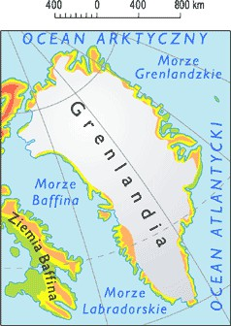**An island** - a landmass surrounded by water on all sides, smaller than the smallest continent, for example, Greenland, the largest island in the world.

**An archipelago** - a group of islands located close

to each other, often sharing a common origin, for example,

the Malay Archipelago.

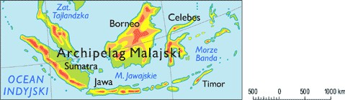

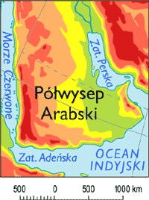**A peninsula** - a landmass that protrudes into a body of water (ocean, sea, lake), surrounded by water on three sides, for example, the Arabian Peninsula.

**A cape** - the farthest protruding piece of land along a particular stretch of coastline, for example, Cape of Good Hope or Cape Point.

