***Volcanoes and earthquakes in Iceland***

1. Based on the map, explain why Iceland experiences volcanoes and earthquakes.

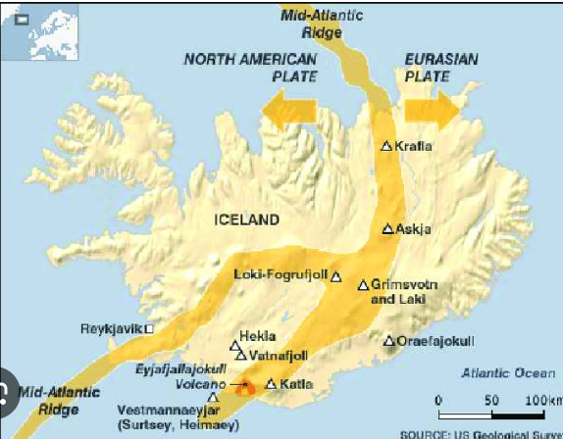

1. Assess whether the provided information is true. T for true, F for false

|  |  |  |
| --- | --- | --- |
| 1 | Iceland is a fragment of the stretching Atlantic Ocean zone, where lithospheric plates are spreading |  |
| 2 | Earthquakes occur due to the fluid movement of lithospheric plates relative to each other |  |
| 3 | The cause of lithospheric plate movement is the shifting of magma currents flowing in different directions |  |

1. Connect the terms with the appropriate explanations

magma, basalt, geyser, lithosphere

outer rigid shell of the Earth, black volcanic rock, hot mass of rock flowing onto the Earth's surface, hot spring ejecting violent columns of water, molten mass in the form of hot liquid deep within the Earth

4)



Ocean:

Plate:

Plate:::

Iceland lies at the boundary of lithospheric plates. Its location has been presented on the map. Perform the tasks based on the information from the textbook.

1. Fill in the missing names on the map

b) Mark in red the zone where the most volcanoes occur,

c) Underline the correct descriptions so that the given information is true

A. In places where lithospheric plates are moving apart, mountain chains/volcanoes and earthquakes occur.

B. The movement of lithospheric plates is the result of the movement of lava/magma underground.

C. Most of Iceland's area is covered by basalt/sand and gravel.

D. As a result of heating groundwater, Iceland has volcanoes/geysers.

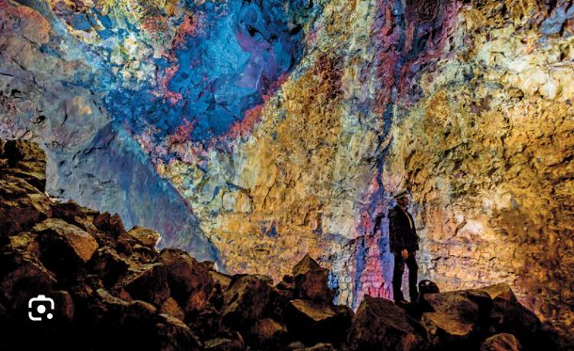

In Iceland, there are active volcanoes, geysers, hot springs, but also glaciers. That's why this island is often referred to as the land of fire and ice. Among the many tourist attractions in Iceland, special attention is drawn to the interior of the extinct volcano Thrihnukagigur. It is located about 30 km southeast of Reykjavik. It is the only volcano of its kind in the world. Its last eruption occurred about 4000 years ago. Currently, the empty interior of the volcano is adorned with hundreds of different colors. Tourists descend inside in small groups. The descent is made through a narrow crevice 120 meters deep.

Task: Explain why Iceland is called the land of fire and ice:

………………………………………………………………………………………………………………………………………………………………………………………………………………………………………………………………………………………………………………………………………………………………………………………………………………………………………………………………

Find two other tourist attractions in Iceland related to volcanoes in additional sources of knowledge. Mark them on the map and describe them

"Remember!

* Iceland lies in the zone of spreading lithospheric plates. As a result of this location, there are volcanoes, earthquakes, geysers, and basalt rocks
* Geothermal sources are utilized by Icelanders for heating homes.
* Some of the biggest tourist attractions on the island include volcanoes, geysers, waterfalls, and glaciers