Iceland's volcanic bread baked for 24 hours underground, fish soup with coconut milk, lobster cream, or sheep's heads – Iceland intrigues not only with its nature and landscapes but also with its cuisine. Icelandic cuisine is, on one hand, simple and limited by ingredient availability, yet on the other hand, it surprises with flavors that one wouldn't expect to find here.

**Brains, heads, and testicles – traditional Icelandic cuisine**

Legends surround traditional Icelandic cuisine. In the past, the island's location and limited transportation options forced Icelanders to eat all parts of the fish and animals living on the island – brains, stomachs, or testicles, nothing could go to waste. Today, dishes like Hákarl – fermented shark, Svið – halved sheep's head boiled after removal of fur and brains, Sursadir hrutspungar – smoked ram's testicles, or statur – meat, fat, and blood sewn in a sheep's stomach, are not meals that an Icelander would prepare for lunch or dinner. The Icelanders we talked to made it clear that these are more of a tourist attraction. We didn't find any of these dishes in restaurants or shops, but we admit we weren't specifically looking for them; we focused on what really tastes good to Icelanders and what the contemporary culinary face of Iceland looks like.

Departing from "culinary peculiarities" certainly doesn't mean that Icelanders have completely abandoned tradition. There are dishes they still indulge in today. Throughout history, to stockpile for the long, harsh winter, fish was salted, dried, and smoked. In the 15th century, dried fish was even used as currency in Iceland. Harðfiskur, or dried fish (usually cod), is almost as popular today as the Icelandic hot dog. You can buy it at every gas station. It tastes somewhat like fishy chips, is incredibly filling, nutritious, and, most importantly, delicious! Much better than Portuguese bacalhau. We regretted bringing only one package with us; it disappeared very quickly. Skyr, a creamy cheese made from skimmed sour milk, is also popular. Unfortunately, we couldn't find it in its traditional form. The one we bought in the store tasted like our homogenized cheese spread and had a similar consistency, but it differed in fat content.

**Rugbrauð – Icelandic volcanic bread**

Our greatest curiosity was piqued by Rugbrauð. This traditional Icelandic volcanic bread, also called lava bread, is baked in an underground, geothermal bakery, where the temperature of the earth and underground springs reaches 100 degrees Celsius. The bread dough is poured into a pot, tightly sealed, buried a meter underground, and left for 24 hours. Underground, the bread bakes, or rather cooks, in hot, volcanic steam. After a day and digging up the pot, the rugbrauð is ready. You can see what such an underground bakery looks like in this video:

Rugbrauð tastes delicious, but entirely different from traditional European bread. The main ingredient of volcanic bread is rye flour, which gives it its characteristic sweet taste. Why rye? Because it is less demanding than wheat and easier to grow in harsh Icelandic conditions compared to wheat. Apart from its sweet taste, the bread also differs in texture; it is dense and quite moist. Volcanic bread is usually eaten with just butter; nothing else is needed! Sometimes it is served with local smoked fish. Near Lake Myvatn, where it is "baked, and where we tried and bought it, it is most often served with smoked trout.

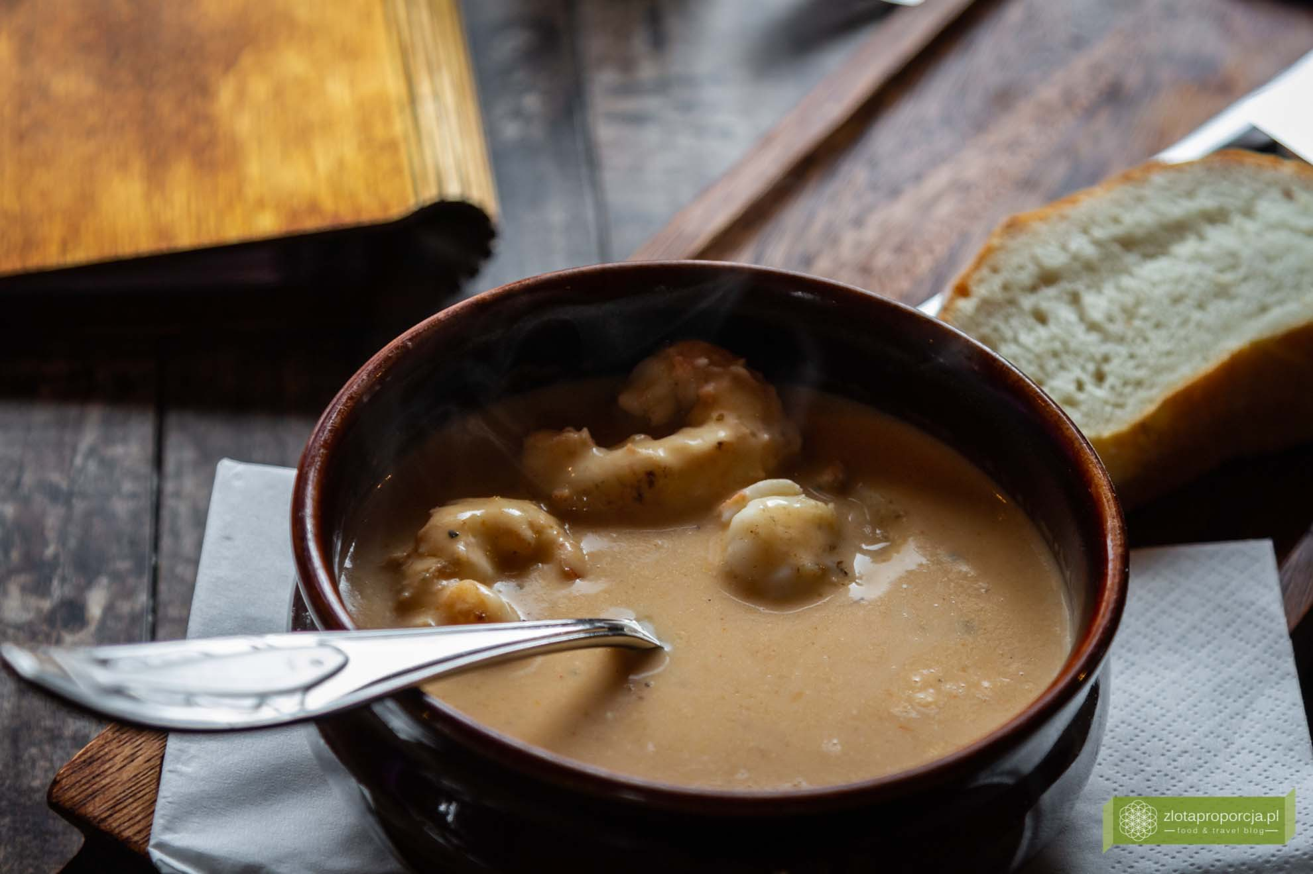

Humar súpa – lobster cream with fried lobster tails and a pinch of anise

**Humar súpa and fish delicacies**

# Icelandic cuisine, due to its island location, is rich in fish dishes and seafood. Lobster is very popular, and Humar súpa, lobster cream with fried lobster tails and a pinch of anise, we tried in no accidental place, namely in a restaurant specializing in lobster dishes in Höfn on the east coast, known as the Icelandic lobster capital. The cream is very delicate and incredibly nutritious, very tasty, but we can't say it won us over. Similarly, the Humarpizza with lobster marinated in garlic, arugula, and fresh tomatoes. The combination of flavors was very interesting, but it lacked a bit for a real Italian pizza. Here's a little curiosity; pizza is sometimes called "pizzur" in Iceland.

# Humarpizza with marinated garlic lobster, arugula, and fresh tomatoes

# Northern Iceland is famous for delicious fish – cod, haddock, salmon, halibut, or herring. In taverns in Husavik, you can eat tasty pieces of salmon or fish skewers. We also indulged in a traditional fish dish – "crushed" fish served with jacket potatoes and volcanic bread. Cod and haddock meat are ground with potatoes, seasoned with salt and pepper, and then baked in the oven. The dish looks like mashed potatoes and tastes a bit like it. It's quite bland; a much better choice is a piece of fresh fish.

# Crushed fish served with jacket potatoes and volcanic bread

# A real rarity turned out to be an incredibly simple and un-Icelandic dish – fish and chips made from freshly caught and mouth-watering cod loins. But if you think it was easy to find them, you are mistaken. Apart from Reykjavik, we only saw them in Skogafoss and Husavik, even though we traveled all around the island. As Icelanders say, fish and chips is British Tradition and Icelandic Quality; it's hard to disagree; we haven't eaten better anywhere else.

# Icelandic street food and the culinary revolution in Iceland

# But it's not fish and chips, but the hot dog, called pylsur here, that is the king of Icelandic street food. You can eat it at every gas station, supermarket, shopping center, or airport. Served with roasted and fresh onions, sweet mustard, ketchup, Icelandic remulade mayonnaise, and soda, it's a true Icelandic national dish. Even Bill Clinton tried it at the famous Bæjarins Beztu Pylsur stand in the old port of Reykjavik, crowded with tourists.

# Until recently, hot dog stands were the only street food stalls in Iceland. But times are changing. After Icelanders took to the streets with pots and pans during the 2008 culinary revolution, the streets and eating habits of Reykjavik residents changed. Food courts with real burgers, lobster soup, traditional meat soup began to pop up like mushrooms. Today, the streets of Iceland's capital tempt with some of the best street food in Europe and relatively low prices for Icelandic standards. We paid around PLN 42 for a large piece of cod loin with fries, which is only slightly less than a few days later on the Tri-City coast. A little cheaper is a hamburger made from juicy beef; pylsur costs PLN 20, and lamb soup about PLN 35.

# The biggest surprise was the fish soup with curry and coconut milk and coconut pastries. Where did the coconuts come from in Iceland? We have no idea. We saw coconut fish soup in many places, but we only ate it in Husavik, ordering it by accident – we thought it would finally be a real fish soup. But even this one was made with coconut milk. It was really good, but in taste, it was more reminiscent of Thai cuisine; when traveling to Iceland, we expected something completely different. The coconut flavor is also noticeable in kleinur, a traditional Icelandic pastry, fried in deep fat and shaped like our faworki.

# Kleinur

# We tried to ask why fish soup is made with coconut milk, unfortunately, no one could give us an answer. We learned, however, that it is an ingredient in one of the traditional Christmas dishes. Sliced and cooked potatoes in their jackets are covered with a sauce made from thick cream, coconut milk, and sugar. In other versions of this dish, mashed potatoes or ham are coated with a cream-coconut sauce. Doesn't sound very Icelandic, does it?

# Finally, a few words about Prince Polo. Do you remember the story of the Cieszyn sandwich with herring? We described how Icelandic herring ended up in Cieszyn and how Prince Polo came to Iceland. In the first store we entered on our first day in Reykjavik, Prince Polo was prominently displayed. We asked the shop assistant if she eats our native wafers. We were told that it is her favorite chocolate bar because "Prince Polo is so good and so simple." We confirm that Prince Polo is the most popular wafer in the country; you will find it in practically every grocery store, gas station, and in sets with pylsur.

# Top of Form