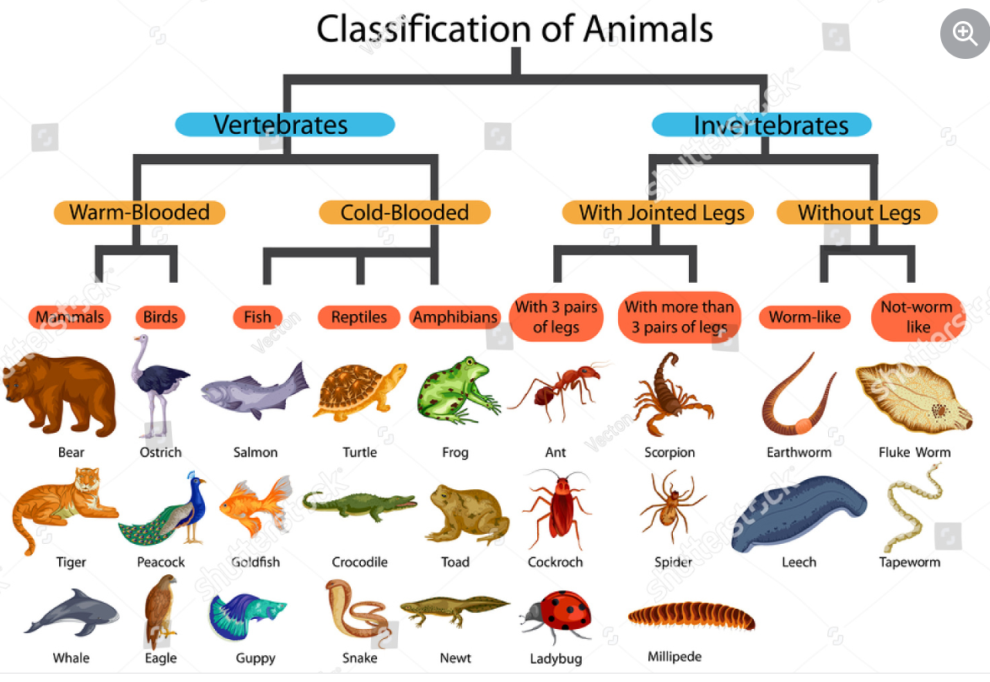

Aristotle was the first to classify animal organisms. He described many species and grouped them based on their morphological similarities. Modern animal taxonomy (similarly to plant taxonomy) aims to create a natural system that considers the relationships between these organisms.