**What is a balanced diet and how should it look?**

The concept of a "balanced diet" appears in every context related to healthy eating. It is most often associated with restrictions and weight loss, but this is a mistaken association. What is a balanced diet? Are there rules for composing it, so that everyone can create their own menu?

**What should a balanced diet look like?**

A balanced diet is a term referring to a nutrition program in which all nutrients are planned in appropriate proportions. It also involves certain restrictions, as it assumes eliminating empty calories from the menu, which do not provide any nutritional value.

The most important elements of a balanced diet include:

• protein,

• fats,

• carbohydrates,

• vitamins,

• minerals,

• fiber.

People concerned with a properly balanced diet should also remember about water - it is an essential element of a healthy diet.

**A Balanced Diet - What Should It Contain?**

Based on knowledge of nutrition and the body's needs, specialists have created principles of healthy eating and proportions of nutrients in various sets, which serve as models for balanced nutrition.

**Healthy Eating Plate**

On October 17, 2020, the National Institute of Public Health presented new recommendations for the first time, which are to replace the previously known healthy eating pyramid. They were collected and presented in the form of a graphic resembling a plate, on which various products are distributed in appropriate proportions. The arrangement also shows their quantitative contribution to the daily diet.

Important: all such recommendations are addressed to people who do not suffer from chronic diseases. In case of diseases or allergies, it is necessary to consult a specialist about balancing the diet.

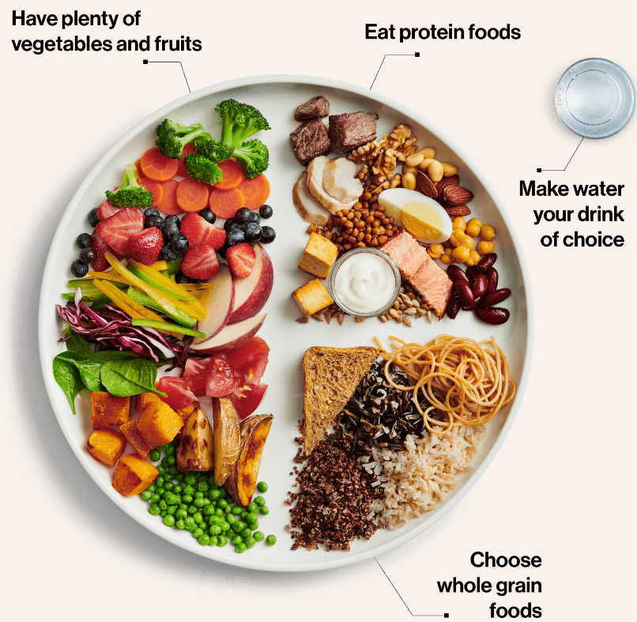

Important: all such recommendations are addressed to individuals who are not burdened with chronic diseases. In case of diseases or allergies, it is necessary to consult with a specialist regarding balancing the diet.

According to the graphic, half of the meal should consist of vegetables and fruits, with more vegetables. This is because fructose - this sugar can linger in the intestines and ferment, leading to bloating and abdominal pain. A quarter of the plate consists of whole-grain products from wholemeal flour, which should be a source of fiber and complex carbohydrates. They stimulate digestion, counteract digestive problems, and cardiovascular diseases. Eating them daily also helps maintain a healthy body weight. The next quarter is sources of protein: poultry, fish, eggs, legumes, as well as milk and its products. However, care should be taken with them due to allergens. Some genetically predisposed individuals should be careful about excess dairy in their diet, as it can lead to skin problems.

Below the plate, there is space for additional comments divided into three parts:

1. Eat more - it explains in a simple and understandable way the information contained in the plate, pointing out individual food groups and describing them.
2. Eat less - a group of products that Poles overuse. Based on research and a review of professional literature, researchers at the National Institute of Public Health have identified the most common poor eating habits of Poles. These include, among others, excess sugar and salt, processed foods, as well as meat (with a special emphasis on red meat) and its products. Frequent consumption of these products is not recommended due to the presence of cholesterol and saturated fatty acids.
3. Replace - it indicates healthier alternatives to popular but unhealthy products.