Small animals living in ponds.
From the muddy bottom to the water surface, ponds and pools are habitats for all kinds of invertebrates, annelids, crustaceans, mollusks, and insects…

Water boatman.
This aquatic bug breathes through a breathing tube located on its abdomen, which it extends above the water surface, positioning itself head down.
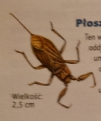

Whirligig beetle.
This aquatic beetle collects air in the form of a bubble under covers at the end of its abdomen.
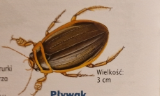

Pond snail.
This snail often lays eggs on the underside of water lily leaves.
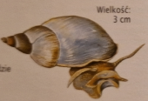

Pond horn snail.
Similar to the pond snail, the pond horn snail is a freshwater snail. With its rough tongue, it will try plant food.
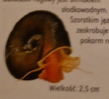

Water flea.
The water flea is a miniature crustacean with a transparent shell.
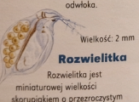

Stickleback.
The stickleback looks truly original. The female stickleback carries two egg pouches on either side of its body.
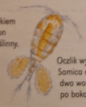

Hunters.
The pond provides shelter for two remarkable species of spider: the raft spider and the diving bell spider. The raft spider hunts insects that fall into the water. It dives well and carries a ball of eggs glued under its body. Meanwhile, the diving bell spider constructs a kind of underwater bell from spider silk, trapping a supply of air inside which it breathes. It replenishes the supply by going under the bell with an air bubble that rises to the top and becomes trapped in the bell. The diving bell spider builds an additional tier above the bell for its eggs.

Predators.
The common feature of the water beetle and the water scorpion is their great voracity and the fact that both catch their prey using their front legs, which close like the blade of a pocket knife.

