Mountain mammals

Life in the mountains has a specific character. It requires from mountain mammals significant adaptive abilities, allowing them to adjust to harsh climatic conditions.

Snow vole

The snow vole is 20 cm long and weighs 60 g. It differs from other voles in its light gray fur color. It is the only vole capable of living at high altitudes. It can be found even at altitudes of 3000 m among well-exposed scree."

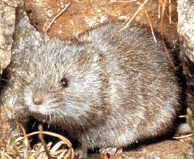

Mountain hare

Not without reason, the Hare carries the charming nickname "bielak". In winter, its fur turns white, except for the tips of its ears, which remain black. It is slightly smaller than the brown hare and has shorter ears. It feeds on grass blades but prefers rocky areas and scree slopes as it's easy to find shelter there. Its tracks and droppings are remarkably similar to those of the brown hare. However, if you come across them in winter at an altitude above 1500 m, you can be sure they were left by the "bielak". The hare's paws are wide and covered with long fur, making it easier for them to walk on snow, almost as if they were moving on snowshoes.

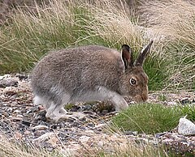

European pine marten

The European pine marten can equally thrive in lowlands as well as in mountains. In heavily snow-covered areas during winter, its fur changes color in the autumn-winter period. It becomes entirely white, with only the tip of the tail remaining black. This allows distinguishing martens from the very similar-looking weasels. You can encounter them up to altitudes of 3000 m above sea level.

Mouflon

The third hoofed animal living in the mountains alongside the chamois and ibex is the mouflon. At 80 centimeters at the withers and weighing from 20 to 55 kilograms, it's only slightly larger than the chamois. The male mouflon has large, curved horns. In very old mouflons, the horns can grow to the height of the eye, almost forming a complete circle.

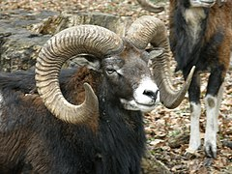

Marmot

It's easy to spot. The mountain mammal you're most likely to encounter is the European ground squirrel. It has the advantage of being active during the day and foraging in mountain meadows, where its silhouette is clearly visible. The ground squirrel is a homebody, so if you stumble upon its burrow, it's worth revisiting. But be cautious. Don't get too close. You might be noticed by the sentinel ground squirrel, who will loudly whistle a warning, prompting the entire community to rush into hiding in the burrow.

At a slower pace. The ground squirrel is a mountain-dwelling, sedentary, and herbivorous animal. When everything is covered in snow during winter, it has no access to food and enters hibernation. To do this, it prepares a cozy nest deep inside its burrow. For 5 or 6 months of hibernation, it will live at a slower pace, utilizing the fat reserves accumulated in autumn.

