Marine mammals.
Like other mammals, marine mammals breathe through lungs, and their young are nourished with their mother's milk. Apart from seals, they spend their entire lives in the water.
Zoology cheat sheet.
Marine mammals are classified into two orders: Pinnipeds and Cetaceans. Pinnipeds include seals and sea lions. Cetaceans are divided into two groups. The first group consists of baleen whales, which have baleen plates used to filter plankton. This group includes whales and humpback whales. The second group is toothed whales, which include sperm whales, killer whales, dolphins, and porpoises.

Two types of diet.
Baleen whales, such as whales, have baleen plates and feed on zooplankton. They open their mouths and suck in large amounts of water. Then they close their mouths and remove the water through the baleen plates, leaving behind the food. Toothed whales, like dolphins, are carnivorous animals and mainly prey on fish and squid. However, killer whales can also consume other marine mammals, such as seals or sea lions.

Those you can see?
Two species of seals living in the Baltic Sea are the gray seal and the common seal. If you sail along the Atlantic Ocean off the coasts of France or Spain, you may see dolphins jumping in the water. The most common species include the Bottlenose Dolphin, Common Dolphin, Striped Dolphin, Pilot Whale, and Porpoise.
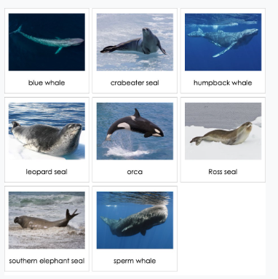
The largest.
The largest animals in the world are marine mammals: the Blue Whale, reaching up to 33 meters in length, the Fin Whale up to 25 meters, and the Sperm Whale and the Giant Whale, which tie for third place with a maximum length of 20 meters.

