Switzerland: Cheese – the symbol of Switzerland

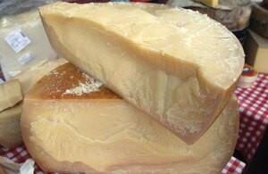

Switzerland is located in the heart of Europe. The Swiss don't like to look at others. It's a small, landlocked country, but it's incredibly independent. The inhabitants of Switzerland are proud and characterized by their attachment to tradition.

Switzerland – one of the Alpine countries and also one of the most mountainous countries in the world. It borders with Germany, Austria, Liechtenstein, Italy and France. When we hear the word "Switzerland", the first things that will probably come to our mind are: watches, pocket knives, banks, chocolate and... cheese! It's safe to say that cheese dominates in Switzerland due to the topography: the vast, mountainous areas that Switzerland occupies make it much more difficult to grow cereals, vegetables or fruit. Since ancient times, the basis of agriculture has been the breeding of cattle, sheep and goats. A lot of experience, combined with excellent knowledge of technology, allowed Swiss cheese to cross the borders of its homeland and appear on the tables of other European countries. At its peak, Swiss cheese was used in Switzerland on a par with gold as a means of payment - cheese was also a foreign currency. The rapidly developing cheese industry could only bring benefits. The cheese trade stimulated local entrepreneurship, and brands known to this day were created, such as Gruyère, Emmentaler, Berner, Oberland, Appenzell.

Emmentaler became the first Swiss brand with a global reach. Unfortunately, there were problems with ownership and patent rights. Due to the lack of appropriate patent law and regulations protecting production, name, etc., cheesemakers from other countries started producing cheese very quickly

similar to Emmentaler, often giving them the same name. High-quality standards were therefore developed that counterfeits could not meet. The emphasis was on quality.

It is estimated that around 450 types of cheese are produced in Switzerland. Each species is distinguished by a characteristic feature: taste, smell, appearance, consistency, origin, length of ripening or production method. Cheeses have various flavor characteristics: they can be spicy, sweet, salty, spicy, mild, herbal, and can also be smoked. The best cheeses are certified - they are granted a document called Appellation d'Origine Protégée, abbreviated as AOP - protected designation of origin. This document strictly defines the rules for producing high-quality cheese. The document confirms that all technological activities leading from raw material, through processing, to the final product were carried out in the indicated region.

The Swiss attach great importance to the quality of milk and the entire cheese production - as the saying goes: "Good cheese begins in the field." The conditions in which cows graze are very important. For cheese to taste good, it must be aged for at least a few weeks to even several years.

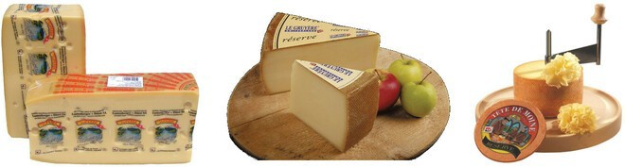

© jansen kaczorowskiciocki Tête de Moine – Monk's Head

This is a truly extraordinary cheese, with a production history dating back 800 years. The first mention of the place of its production dates back to the Swiss Jura region. Currently, only a few traditional, local dairies produce Tête de Moine. In addition, the Monk's Head has the above-mentioned AOP/AOC quality certificate - which reserves the product name for a specific region, from raw material originating from this specified region. It is produced in a traditional way, appropriate for a given cheese, while maintaining appropriate production conditions. When it comes to Tête de Moine, it is impossible not to mention the unusual way of serving - the cheese is given the shape of characteristic rosettes, obtained thanks to special knives called Girolle, which have been designed to be suitable for cutting thin fragments not only of cheese, but also of chocolate flakes in the form of chocolate discs. In fact, there are some similarities between cheese and chocolate

not only in terms of cutting the mentioned knife into decorative florets resembling broccoli florets, but also in the way of serving cheese or chocolate as a hot liquid mass called fondue.

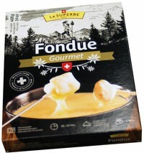

In the case of Fondue, this dish is nothing more than at least two types of melted cheese with the addition of white wine. You can also add a small amount of potato flour, which facilitates emulsification of the resulting cheese-wine mass and prevents undesirable separation. Cheese fondue is usually seasoned with white pepper, garlic and nutmeg. Fondue is also a specific way of eating - it is served in a special pot called caquelon, the bread put on a fork is dipped in the cheese and wine mass. The whole thing is placed over the flame, on a special stand. For fondue, you can also buy special forks for stuffing pieces of bread. Founde with chocolate as the main ingredient is melted chocolate in which pieces of fruit skewered on a fork or a wooden stick are dipped: bananas, strawberries, pineapple, kiwi, oranges, prunes or grapes. A variation of chocolate fondue is a chocolate fountain - setting the chocolate in motion prevents it from congealing and allows tasting for a long time (depending on needs), for example at large parties. Founde can also be made in meat form, pieces of meat are stuffed onto a fork and the cheese mass is replaced with hot oil.

Jansen Kaczorowski Cichocki has a wide range of cheeses from Switzerland. In addition to cheeses such as Emmentaler, Gruyère, Appenzeller and Raclette, you will also find such gems as Shepherd's Pride and Alpejski Kwiat. Here are selected specialties from Switzerland:

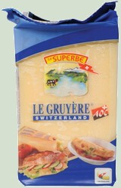

* Alpine Flower Bargbluemli, 4.5 kg
* Appenzeller Classic, 6 kg
* Appenzeller Extra, 6 kg circle
* Diabolo, 4.5 kg
* Pride of the Shepherd Sannachas, 7 kg
* Swiss Emmental, 3 kg
* Fondue Le Superbe, 400 g
* Gruyère, 2.5 kg
* Gruyère Reserve, 3 kg
* Gruyère Reserve, 33 kg circle
* Gruyère, 200 g
* Swiss raclette, 5 kg circle
* Saint Christoph, 2 kg
* Tête de Moine, 0.9 kg
* Tilsiter Red, 4 kg.

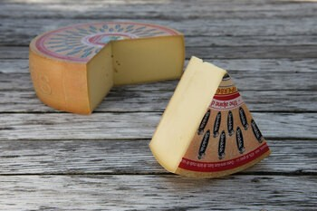

Original Gruyère cheese

Gruyère cheese is a cheese from a town called Gruyères located in the canton of Freiburg. This well-known and valuable Swiss cheese is made from unpasteurized milk. It is a long-ripening, semi-hard cheese. Over time, the taste and aroma change and become more and more rich. Young Gruyères cheese is sweet, has a nutty smell and a fruity, sweet taste (with a touch of salt). At the same time, it is slightly spicy. Its taste goes great with beer. To produce a wheel of cheese weighing approximately 35 kg, no less than 400 liters of milk are needed. The first mention of the production of this cheese dates back to the 12th century. It is characterized by excellent melting properties - perfect for baking or fondue. The cheese ripening period is from about 3 to about 12 months.

The real cheese is produced right on the pasture. According to the old tradition, it is kneaded over an open fire, and to reach its final maturity it is stored in cellars, which provide the best storage conditions. The detailed recipe for producing this delicious cheese remains a secret. It adds flavor to dishes and is perfect for baking and fondue. It is slightly spicy, expressive, unique in taste and yellow in color. Interestingly, the production of Gruyère cheese uses cow's milk with a higher fat content than in the production of other cheeses. The use of fattier milk contributes to the creation of an even sweeter, nutty, slightly buttery aroma. When Gruyère matures for about 10-12 months, it is covered with a characteristic brown-golden skin. Inside, Gruyère is a light yellow cheese with relatively small holes - much smaller than, for example, Emmentaler. The eyes of Gruyère cheese are finer and more regular. This is the result of the eyes shrinking during the ripening of the cheese. This cheese is produced in the form of very large wheels and sold as wedges.

Undoubtedly, Gruyère cheese is an interesting option for a foreign cheese board. It goes very well with light alcohols, for example served with light, fruity wines. It also tastes great as an addition to soups, crispy, fresh bread or dishes using its melted form. It should be emphasized that the original Gruyère cheese comes not from France or Greece, but from Switzerland! However, Swiss Etivaz cheese is the younger brother of Gruyère cheese. This delicious Alpine cheese is rich in aroma and its taste is slightly fruity - somewhat reminiscent of hazelnuts.

Some of the most popular types of cheese from Switzerland include:

1. Emmental: A semi-hard cheese with characteristic large holes and a nutty, slightly sweet flavor.
2. Gruyère: Another semi-hard cheese known for its rich, creamy texture and distinctively nutty taste.
3. Appenzeller: A spicy, aromatic cheese with a strong flavor, often characterized by a slightly sticky rind.
4. Raclette: A semi-firm cheese commonly melted and scraped onto potatoes, vegetables, or bread, with a smooth, creamy texture and a slightly pungent flavor.
5. Tête de Moine: A semi-hard cheese that is traditionally shaved into delicate rosettes using a special tool called a girolle, with a buttery, nutty taste.
6. Sbrinz: A hard cheese similar to Parmesan, with a sharp, robust flavor and a grainy texture.
7. Vacherin Fribourgeois: A semi-soft cheese with a creamy texture and a mild, slightly tangy flavor, often used in fondue.
8. Tomme Vaudoise: A semi-firm cheese with a smooth, creamy texture and a mild, buttery flavor.

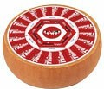

Fun stiff Switzerland

Let's stop discovering the cheese secrets of Switzerland for a moment. This country, armed to the teeth with mountains, hides many interesting facts in its corners, and since the Swiss generally do not like to brag, we may not realize that Switzerland is not as far away from us as it might seem. at first glance. Let's start with cheeses - their names may be difficult to speak, but not to consume.

Meals

The terrain and related weather conditions have the greatest impact on Swiss cuisine. Mountainous Switzerland is a country with agricultural and pastoral traditions, and the country's natural resources have been and are fully exploited. It is therefore not surprising that on tables in Switzerland we can find products of animal origin: mainly cows or sheep, meat from farmed animals and fish caught in rivers and lakes. The high caloric value of the products was caused by the fact that food was supposed to provide the body with a sufficiently high amount of energy, giving strength for long hours of work. The basis of most dishes served in Switzerland are cheeses, which come in various forms, depending on their purpose.

When it comes to dishes, it is worth paying attention to such delicacies as: Rösti, Raclette, Marroni, Vermicelles or Wähe. It is worth noting that these dishes are not intended for people who care about their figure and count every calorie. Swiss cuisine is filling and fattening. Relatively few Swiss dishes are known in Poland, and the most popular is the previously mentioned fondue - although in this case too, mistakes and fondue are often attributed to France. This is an obvious mistake. A short review of tasty and unknown dishes will allow us to broaden our taste horizons a bit, perhaps including a few that we will add to our list of favorite dishes.