Faster and higher.
Ski champions compete in various competitions. The best compete in the Winter Olympic Games and the World Cup.
Cross-country skis are long, light, and narrow. Only the front of the boot is attached to them.
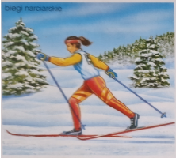

Ski jumping skis are wide and long, and jumpers launch themselves off the ski jump without poles.
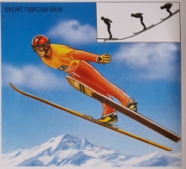

Athletes push heavy metal sleds during the race, then jump into them and speed down the icy chute.
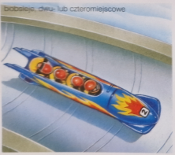

This discipline combines cross-country skiing with rifle shooting in both standing and prone positions.
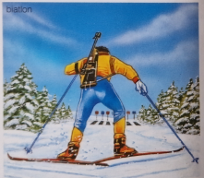
Preparing courses for alpine competitions requires the work of many people. Trails need to be marked, gates placed, dangerous areas secured with nets, and snow packed.
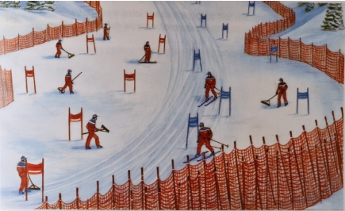

Skiers must pass gates on either side; if they miss even one, they are disqualified. Special slalom consists of two runs.
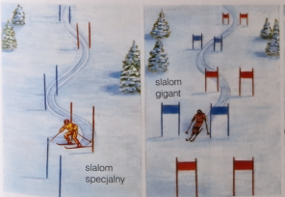

Competitors race down the slope at speeds exceeding 100 km/h.
