Freestyle skiing is a new discipline that requires training in many areas, including aerial jumps, mogul skiing, and ballet on skis.
The mogul course is short and steep. Skiers race against the clock, making various turns. Skiers launch themselves off a ramp over 10 meters high, perform flips in the air, and land on skis. Athletes on short skis perform dance steps and acrobatic maneuvers to the beat of music.
Speed skaters practice speed skating, wearing tight suits, racing on a track. The longest competition is a 10 km race.
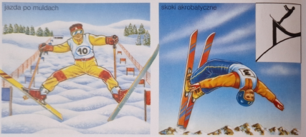
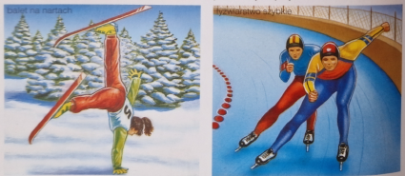
Record-breaking.
Some engage in extreme skiing, attempting to break records by descending from the summit faster than a race car or tackling increasingly steep slopes. Downhill racing takes place on a 1 km track. The fastest run over a 20m section is counted. The current record stands at 251.4 km/h.
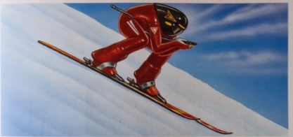
One daring skier descended the steepest face in the Mont Blanc massif. Another managed to ski from the highest altitude of 8770 meters, descending Mount Everest from the south.
