**For health by the Baltic Sea**

A trip to the seaside is a good way to spend a vacation and improve health. A change in climate and clean air saturated with iodine is a recipe for boosting immunity, both for children and seniors. Also, bathing in the salty sea water has a beneficial effect on the body. Perhaps it's worth returning to the tradition of annual relaxation by the Baltic Sea?

The trend and availability of trips to foreign destinations, to the so-called warm countries, have caused many people to forget about the charms of vacationing by the Polish sea. However, relaxation by the Baltic Sea offers something particularly valuable - namely, a climate that greatly benefits health.

**Why the Baltic Sea**

Fans of vacations in Bulgaria or Croatia will say that you can inhale iodine by any sea. This is true, but there is incomparably more of it by the Baltic Sea and other northern seas. The reason for this is the windy weather and higher waves, which contribute to the formation of beneficial aerosol mist. For the same reasons, a lot of iodine is found by the shores of oceans, where the waves are the largest.

**How does it actually work**

The beneficial effect of the maritime climate on health is determined by the so-called sea aerosol. What is it exactly? These are water particles that get into the air when the waves splash. Thanks to this mechanism, there is many times more iodine in the air above the sea than in areas located more centrally. In addition, a trip to the seaside involves a climate change, which is a special stimulus for the body and forces it to adapt to new conditions, thereby promoting more energetic functioning. It's a form of training that improves the functioning of the body, especially the immune system. The coastal climate exceptionally benefits the health and immunity of the youngest - however, it should be remembered that the stay should last at least two weeks for a child's body to fully benefit from it.

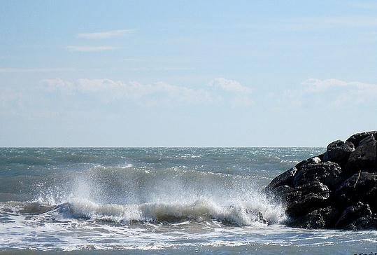

Sea aerosol is formed when waves hitting the shore splash and carry water droplets and minerals with them. The range of sea aerosol occurrence is 200-300m from the shore.

**What is the purpose of iodine in the body**

In coastal air, you can find many health-promoting components, such as bromine, calcium, and magnesium. However, the most important is iodine, as it is essential for the proper functioning of the thyroid gland. The thyroid gland produces hormones that influence many body functions. They regulate metabolism, the functioning of the nervous, muscular, and circulatory systems. The thyroid also affects mental condition, proper weight, and body temperature. Therefore, it is important to maintain the proper level of iodine in the body. It can be obtained from food, so it is recommended to use iodized salt and regularly consume fish and seafood. However, even a good diet may prove insufficient.

**Health problems with iodine deficiency**

Iodine deficiency leads to hypothyroidism. When symptoms such as lack of energy, fatigue, emotional instability, weight gain, poor condition of hair and nails, palpitations, and tremors in the extremities appear, it may indicate a lack of iodine in the thyroid. This should not be ignored; it is best to replenish iodine deficiencies by the sea. Untreated hypothyroidism can cause anemia and problems with the functioning of the heart and lungs. It is a disease that can be effectively treated, but therapy takes a long time. In such cases, it is necessary to take iodine tablets and supplement hormone deficiencies, so it is better to prevent it by maintaining a proper diet and resting by the sea.

**An excellent place for the sickly and allergic**

The seaside climate is not only about iodine and improving immunity. The list of conditions in which treatment is helpful includes the aforementioned hypothyroidism, respiratory and skin diseases, rheumatism, osteoporosis. The sea breeze allows for good oxygenation of the body, deepens breathing, and increases the surface area of the lungs used by the body. Additionally, the sea air moisturizes the bronchi and lungs, helping to cleanse them. This is extremely important, especially for residents of large cities and industrial areas who are exposed to daily contact with pollutants. A stay by the sea is also a real relief for allergy sufferers. The sea breeze brings clean, pollen-free and pollution-free air, so the period of the highest emission of allergens can be endured by spending a lot of time on the beach. A seaside stay also soothes nerves excellently; the sound of waves, beach walks are a real relief for stressed and emotionally exhausted individuals.

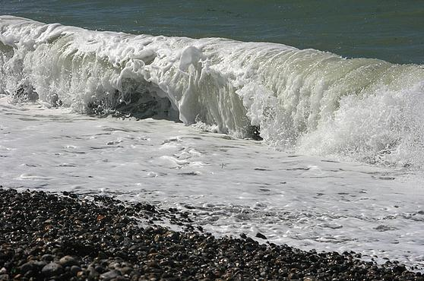

The wind from the sea brings air free from pollutants and pollen, which is why a stay by the sea is recommended for allergy sufferers, especially during periods of increased allergen emissions.

**How to make the most of the good climate**

The highest concentration of iodine is right at the edge of the sea, so beach walks are recommended if the weather doesn't allow lying on the sand. Interestingly, the highest amounts of iodine are found in the sea air between November and March, so more and more people are now taking winter trips to the seaside for health reasons. Paradoxically, from a health perspective, the best weather by the sea is poor, stormy weather. In such conditions, the air contains the most valuable elements, so even on such a day, it's worth putting on a windbreaker and going for a walk instead of sitting in a closed guesthouse.

**Benefits of bathing in seawater**

A stay by the sea is much more than just a change of climate and iodine in the air. There is also power in seawater, which contains plenty of minerals that have a beneficial effect on health and beauty. Bathing in the sea works wonders for the skin, stimulates cellular metabolism, improves hydration, circulation, nourishes, and enhances its elasticity. It's a true rejuvenating treatment that can be continued at home using cosmetics containing sea salt. Bathing in the cold waters of the Baltic Sea relaxes and loosens the muscles, improves circulation and metabolism, which helps in losing extra pounds. Such a bath, along with the clean sea air, also has a surprising effect on stimulating the appetite, which will please parents of picky eaters.

**Sand, water, sun**

A stay at the Polish seaside is still a good idea for a successful vacation and a chance to improve health for both children and adults. The sun stimulates the production of vitamin D and adds energy, while wading in the cool sea water relaxes and has a beneficial effect on the circulatory system, preventing varicose veins. Meanwhile, every long walk along the sandy beach massages the feet, and the sound of the sea soothes. People who are used to summer vacations in warm countries should go to the Baltic Sea at a different time, even in winter. Then you can truly enjoy the peace, deeply breathe the clean air with iodine, and build up the body's immunity to ensure health and well-being for the rest of the year.