Scenario
High-mountain landscape of the Tatra Mountains

I. Introduction
1. List and indicate on the map of Poland geographical regions
2. What are the characteristics of mountain landscape? - knowledge consolidation

II. Development
1. Tatra Environment - nature film, based on which students in groups search for more detailed information on the following topics:
- terrain relief,
- land cover,
- mountain weather,
- flora and fauna of the Tatras,
- vegetation zones,
- Zakopane and regional legends,
- Podhale region and architecture,
- ethnic group and highlander costumes,
- music and dialect.
2. Based on the information gathered by the groups, we create a mind map together
- draw on a large sheet of paper.
3. Lakes, rivers, and waterfalls in the Tatra Mountains
- browsing through nature albums - interesting facts
- fish - methods of preparation, storage methods, and nutritional values - group work,
- for those interested, tasting of smoked fish.
4. Tatra National Park - its emblem - why do we protect nature?

III. Summary
1. Highlander hat, called "kłobuk".
2. Color traditional highlander costume - art project.

Individual work

1. Explain what the term "oscypek" means. What other names do cheeses produced in the mountains have?
- write down in your notebook the nutritional values of the cheese you have chosen.
Oscypek (Polish plural: oscypki), rarely Oszczypek, is a smoked cheese made of salted sheep milk exclusively in the Tatra Mountains region of Poland. Oscypek is made by an expert named "baca", a term also denoting a shepherd in the mountains. The cheese is a traditional holiday cheese in some European countries and is often pan fried and served with cranberry jam (żurawina) on the side.
2. History of mountaineering - task for volunteers.
High-mountain landscape of the Tatra Mountains
1. Characteristics of mountain landscape: strongly undulating terrain,
very high relative elevations,
narrow, winding, fast-flowing rivers,
vegetation in zones.
THE CARPATHIANS:
Polish Tatras (Rysy 2499m above sea level): Beskid Mountains
medium mountains
Western Tatras (High Tatras
lower mountains, high-mountain landscape
karst relief,
)( mountain pass sign

Carpathians - a mountain range in southern Poland.

High Tatras - sharp, pointed peaks and ridges,
- mountain valleys,
- mountain streams (flowing quickly),
- waterfalls, e.g., Wielka Siklawa,
- mountain lakes (remnants of glaciers),
- built of hard granite rocks,
Western Tatras - a lower range, more "smoothed",
- built of soft limestone rocks,
- limestone rocks are dissolved by rainwater and flowing (rivers),
- karst relief (caves, various rock forms).
Karst - dissolution of limestone rocks by water.

Vegetation zones in the Tatras:
lower regiel - up to 1250 m above sea level, mixed forest
upper regiel - from 1250 to 1600 m above sea level, coniferous forest
dwarf mountain pine - from 1600 to 1800 m above sea level, low coniferous shrubs
alpine meadows - from 1800 to 2250 m above sea level, grassy meadows
rocky ridges - above 2250 m above sea level, bare rocks, mosses, lichens
Mountain weather - it is colder in the mountains, the temperature decreases with
increasing elevation above sea level (0.6 degrees Celsius per 100 m)
- more precipitation
- strong winds
- foehn wind - warm, strong wind from the south
- so-called weather breaks

Waterfall - flowing water in a river encounters a large difference in terrain height,
sudden drops or ledges - falling water creates waterfalls
or cascades, water falls with a roar, splashing and foaming.

Vegetation of the Tatras - lower regiel: spruce, beech, and fir forests,
upper regiel: spruce forest,
dwarf mountain pine zone: shrubby vegetation dominated by mountain pine,
alpine meadow zone: low grasses with rich alpine vegetation, e.g.,
Gentiana, alpine carnation, alpine pasqueflower,
rocky ridge zone: little vegetation, e.g., glacier buttercup, transparent gentian.

Animals of the Tatras - chamois, ground squirrel, below deer, European roe deer, lynx,
weasels, brown bear; among birds - golden eagle,
and wallcreeper (has red wings).

Endemics - a group of organisms unique to a particular place or region.
Plant endemics - Tatra chickweed, grasses: Tatra fescue
and blue fescue; eight-petal sedge
and narrow-leaved willow are relics of the ice age

Podhale - a cultural highlander region at the northern foot of the Tatras.

Architecture, e.g., Chochołów has a historic architecture, these are wooden cottages,
traditionally they wash wood with soapy water

Zakopane - the main town of this region, has about 28,000 permanent
residents; tourists come all year round (over 100,000 people),
the ethnic group is highlanders - different from other residents of Poland in culture,
art, architecture, costumes, customs, and language - they use a dialect.

Highlander costume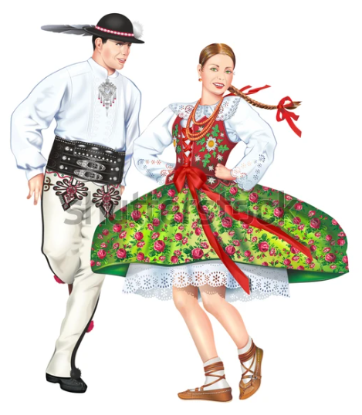

Nine-stemmed avens - a common motif in highlander costumes, but also a medicinal plant,
already in the Middle Ages the root was used as a diaphoretic, diuretic; and in art
culinary (in Switzerland and Italy) the bottom of flower baskets was eaten as a vegetable.

Mountain stream fish - brook trout, spotty gudgeon,
Brook trout, grayling, brook trout, lake trout.
Nutritional values of rainbow trout

Worksheet
1. Using a tourist map of the Tatras - locate the following geographical objects:
Kasprowy Wierch, Zakopane, others.

Crossword clues
From the given words, select only 10 terms to create a crossword puzzle.
Podhale, rocky ridges, alpine meadow, stream, brook, waterfall, dialect, highlander,
Terrain, weather, cottage, costumes, karst, cave, limestone, granite,
Mountain, peak, ski lift, bandit, grotto, peak, regiel, mountain pine, eagle,
ground squirrel, chamois, wolf, bear, fish, trout, pond, lake, glacier,
endemic, relic, slope, valley, ski jump, spruce, pine, forest, grass,
snow, foehn, hat, leather moccasins.

