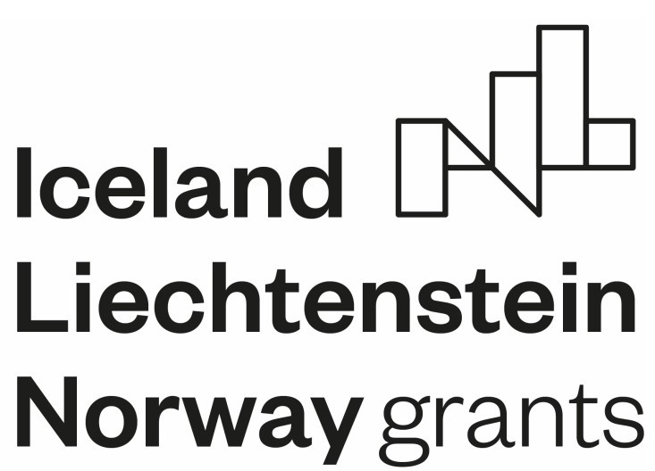LESSON SCHEDULE:

|  |  |  |  |  |
| --- | --- | --- | --- | --- |
| **PUBLISHED PART:** |  | | | |
| **ITEM:** | □ NATURE | | | |
| **TARGET GROUP:** | □ 6th GRADE STUDENTS | | | |
| **TOPIC:** | **Culture of Spain** | | | |
| **GENERAL PURPOSE** | Getting to know the natural environment, customs, monuments and cuisine of Spain | | | |
| **OPERATIONAL GOALS** | Student   * lists factors affecting the natural environment, * analyzes and compares various phenomena based on charts, tables and thematic maps, * reads terrain heights from the map, * characterizes individual regions based on articles, * uses the names of geographical directions, * compares European cities. | | | |
| **METHODS** | * Lecture * Movie | | | |
| **FORMS:** | * Presentation slides | | | |
| **TEACHING RESOURCES:** | | | | |
| ☒ Presentation | **X Individual exercise**: : | **X Group exercise:** | □ **Quiz** | □ Test |
| □ Multimedia task on  **platform** | □ Test | □ Infographic | **X Film fragment:** | □ Animation |
| **downloadable worksheet** | □ Poster | □ Board: | □ Other: | □ Other: |
| **DESCRIPTION OF THE LESSON** | Description of the lesson  Spain - the country in Europe with the highest number of obese people. Every second woman and almost 70% of men have a problem with being overweight. Every third child also suffers from it. This is the highest rate of overweight among children.  Spanish traditional cuisine is considered one of the healthiest in the world. However, fresh meat and fish are increasingly replaced by semi-finished products, and vegetables and fruit are rarely eaten.  Especially among children who, according to doctors, increasingly often have cholesterol problems.  The greatest advantage of the Mediterranean diet is unsaturated fats. They don't make you fat. | | | |

However, children and adults prefer food that has no value. The World Health Organization appealed to Spain to return to traditional cuisine. According to its experts, unless the inhabitants of the Iberian Peninsula change their habits, in 10 years 80% of men and 60% of women will be at risk of obesity.

1. Introduction.
   1. National Spanish dances - flamenco, paso doble, bolero, iota

* dance lessons - documentary film (fragments) 2.Spanish customs and interesting facts about Spanish culture

3.Location of Spain in Europe - indicate the country's location on the thematic maps

1. Development.
   1. Preparing a guide to Barcelona – working in groups on various topics of the guide
2. group - searches for information about Spanish cuisine, pays attention to the culinary regions of Spanish cuisine, descriptions and photos of dishes
3. group – deals with the topic of Barcelona's monuments, descriptions and photos
4. group - what is a marketplace? the oldest market in Barcelona, ​​fruits, cheeses (Cabrales, Majorero, Manchego, La Serena, San Simon) descriptions and photos
5. group – natural environment of Spain,

Animals - bear, shark, killer whale, jellyfish, scorpions, spiders, snakes, vipers,

* cnidarians (jellyfish)
* arachnids – arthropods (scorpion) descriptions and photos
  1. We prepare materials for the guide on A4 paper, a uniform format, so that it is easy to fasten (sew) all the material into one whole. We do not mark Barcelona's monuments on the city map, this is just information about what you can see.
  2. Submission of the "Barcelona Guide".
  3. Spanish songs - getting to know Spanish melodies. 5.Traditional Spanish costume - women's and men's - illustrations.

1. Summary. 1. Healthy drinks for children

2.Rainbow on a plate – experience:

Place Skittles candies in the shape of a circle on a large flat plate, then slowly pour water onto the plate so that the candies are half submerged; now we have to wait (we don't move the plate) until the candies color the water.

own work

1. Based on the information from the classes, design a postage stamp thematically related to Spain or a menu cover (concerning Spanish cuisine).