Medicinal Plants.
Some plants found in Poland are used for medicinal purposes due to their properties. Depending on the species, their flowers, fruits, shoots, or roots are used. Many medicines and cosmetics also contain substances of plant origin.
Calendula. Compresses made from calendula are helpful in treating ulcers and burns. It is also used to treat liver ailments.

Common St. John's Wort. Common St. John's wort is helpful in treating stomach, gallbladder, and liver ailments. This plant also has a calming effect.
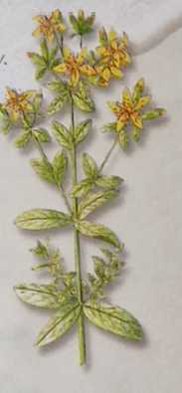
Lemon Balm. The leaves of lemon balm are used to treat gastrointestinal ailments and have calming and sedative effects.

Foxglove. Medications made from foxglove are used in heart conditions, but only under strict medical supervision because the entire plant is poisonous.

Linden. Linden flower tea can be used as a fever reducer. Linden also has diuretic and calming effects.
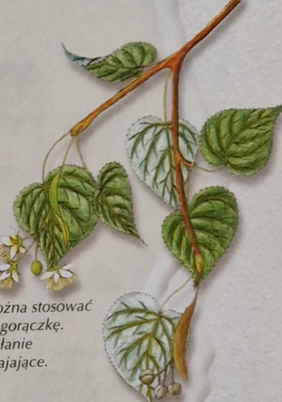

Shrubs.
Shrubs are plants with woody stems, which, unlike trees, do not have a trunk or a crown. Shrubs are very common in Poland and can be found in forests, parks, gardens, along roads and railways, and even in wastelands and landfills. Some of them have medicinal properties.
Guelder Rose. Guelder rose is a shrub with white flowers and beautiful, but poisonous, coral-colored fruits.

Field Rose. The field rose, also known as the wild rose, is a very thorny shrub, closely related to a vast number of decorative rose varieties.
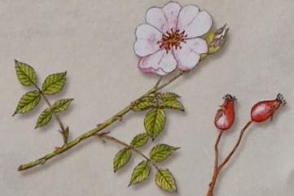
Common Elder. Common elder is increasingly found on forest edges, roadsides, wastelands, and even landfills. A decoction of its flowers has diaphoretic and diuretic properties.
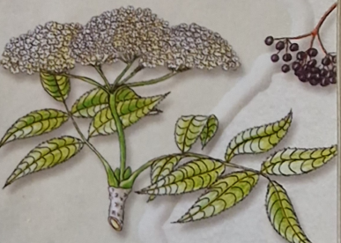
Red Raspberry. The red raspberry grows in clearings and forest edges. It is valued for its clean, sweet, and aromatic fruits.

Hawthorn. The single-seed hawthorn often grows in thickets, parks, and hedges, producing small, edible red fruits. Due to their properties, hawthorn flowers and fruits are frequently used in heart medications.


