In contrast to trees and shrubs, herbaceous plants, lacking woody stems, are flexible and delicate. In our climate, the above-ground parts of these plants die off in the winter. Among herbaceous plants, we distinguish between annual, biennial, and perennial plants.
Ferns (various types)
A PNW classic, ferns – which include sword ferns, deer ferns, maidenhair ferns, and more – are an excellent shade-friendly option that looks great in virtually any circumstance. Planted close together, the can act as a groundcover, filling bare or unused garden spaces with unique textures and foliage.
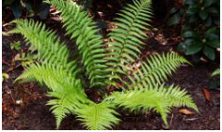
Plantain Lily (Hosta sp.)
Another shade-friendly perennial, hostas come in a range of different colours including yellow, green, and blue, with broad, often variegated leaves and small white flowers in the spring and summer. In the right conditions, they can grow up to four feet in diameter, and look great planted near a garden’s edge at the base of taller plants.
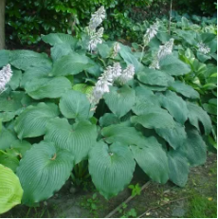
Daylilies (Hemerocallis sp.)
Another great option for a perennial groundcover, daylilies are a staple in many gardens. Flowers can be very colourful, and they attract pollinators in the spring and summer. They’re hardy, but prefer sunny areas.
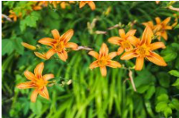
AstilbeAstilbe (Astilbe sp.)
With bright flowers and slender, fern-like foliage, astilbe are another excellent option for a shaded area. Where other shade-tolerant perennials tend not to flower (or else flowers are very small), astilbe are bright and vivid, making your shady areas look like a full-sun pollinator garden.
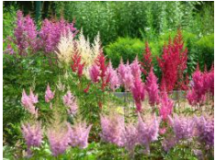
Hakone grass (Hakonechloa macra)
Most grasses are extremely versatile; they can be used as groundcovers, accents, feature plants, and more. Even among other grasses, though, hakone grass stands out. With bright green foliage that grows in a dense mound, it stands out especially well when it foregrounds darker-coloured plants.
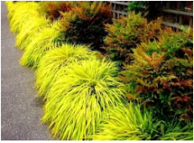
Black-eyed susan (Rudbeckia fulgida)
Another perennial classic, black-eyed susans are sun-loving, with dense green foliage and tall black and yellow flowers. If you’re looking for pops of bright summer colour in your landscape that don’t distract from your feature plants, clusters of these herbaceous perennial are an amazing option.
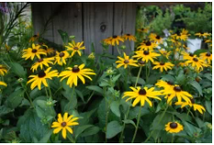
Coneflower (Echinacea sp.)
With similar overall shape to black-eyed susans, echinacea grow tall and pink with a flower the slightly resembles a badminton birdie. They’re excellent for attracting pollinators like bees and butterflies, and they thrive in sunny areas.
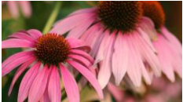

Shasta daisy (Leucanthemum x superbum)
With simple clusters of white flowers, shasta daisies are an unassuming addition to any landscape, adding flowery clusters of sun-friendly interest.
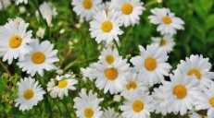

Feather reed grass (Calamagrostis x acutiflora)
For a light vertical texture, look no further than feather reed grasses, which grow thin plumes of unassuming, wispy foliage. They’re low maintenance, hardy, and they look great.
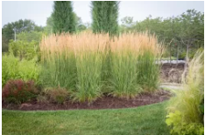

Salvia (Salvia)
A fragrant and aromatic pollinator plant, salvia grows thin purple flowers from clusters of bright green foliage. Plant near rocks and boulders to make them really stand out.
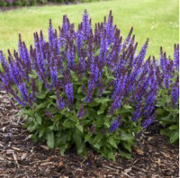

The natural conditions prevailing in Poland are exceptionally favorable for the presence of various species of trees. If not for human activity, forested areas would cover almost the entire country.
Norway Spruce. The Norway spruce is a common tree found throughout almost all of Poland. Its wood is used in construction and paper production.
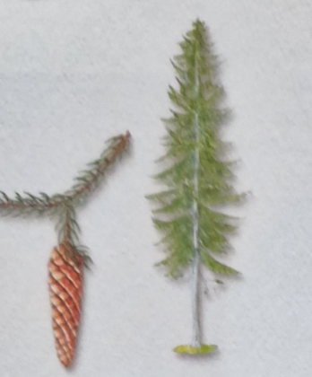

Scots Pine. The Scots pine is the most common tree in Poland.
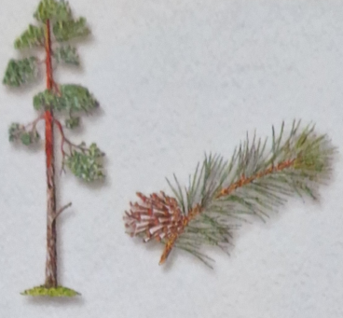
Maple. The maple can be found in parks as well as in deciduous forests across the entire country.
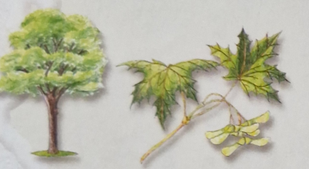
Ash. The ash is a majestic tree with flexible wood that has various uses.
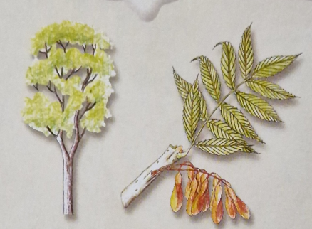

Silver Fir. The silver fir is sensitive to air pollution and is therefore becoming increasingly rare.
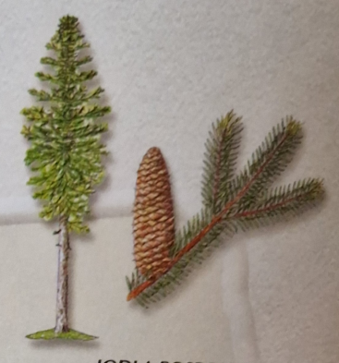
Swiss Pine. The Swiss pine is a rare and protected tree that grows only in the mountains.
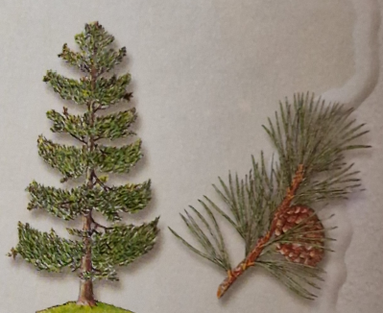
Oak. The oak is a long-lived tree that can reach impressive sizes. Its wood is among the hardest and most valuable.
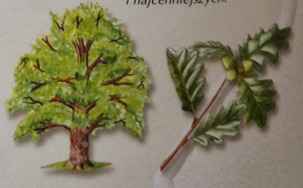
Birch. The birch is a popular tree throughout Poland, distinguished by its white bark.
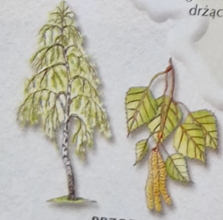
Horse Chestnut.
The horse chestnut, known for its beautiful flowers, impressive leaves, and seeds called conkers, is often planted in parks and along roadsides.
