Garden Plants.
Ornamental plants in our gardens and parks originate from regions with a temperate climate. They are cultivated for their beautiful leaves, flowers, fruits, fragrance, or the striking appearance of the entire plant.
Chrysanthemum. The chrysanthemum blooms from summer to late autumn, adorning the garden with a wealth of colors.
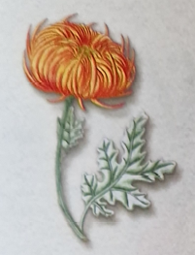
Hydrangea. The flowers of a properly cultivated hydrangea change color from green through pink and red to blue.
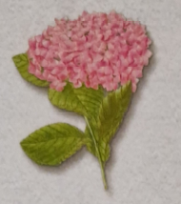
Hyacinth. The hyacinth blooms in spring, filling the garden with an intoxicating fragrance.
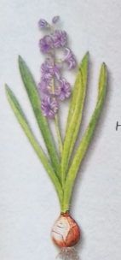
Dahlia. The dahlia is an ornamental plant distinguished by a huge variety of flower shapes and colors.
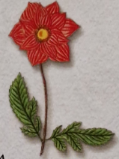
Rose. The rose is often considered the most beautiful plant in our gardens.
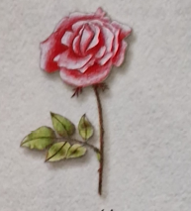

Potted Plants. In natural conditions, potted plants thrive in warm climatic zones. They require high and constant temperatures for cultivation, which is why they must be grown in apartments or greenhouses.
Monstera deliciosa. Monstera deliciosa, often mistakenly called a Philodendron, is a climbing plant imported from tropical America.
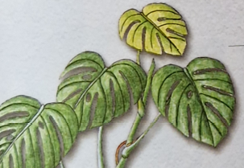
Ficus. Ficus is known in Poland as a potted plant. In Southeast Asia, where it originates, it can reach a height of 30 meters.
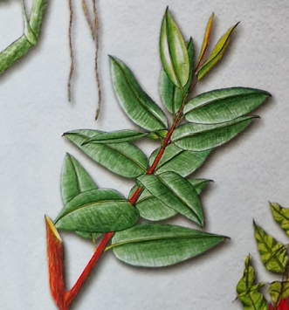
Geranium. Geranium blooms throughout the summer, and its leaves emit a distinctive, intense fragrance.
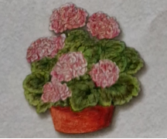

Fern. The fern tolerates the lack of sunlight indoors but requires moist soil and air.
