forms of bacteria

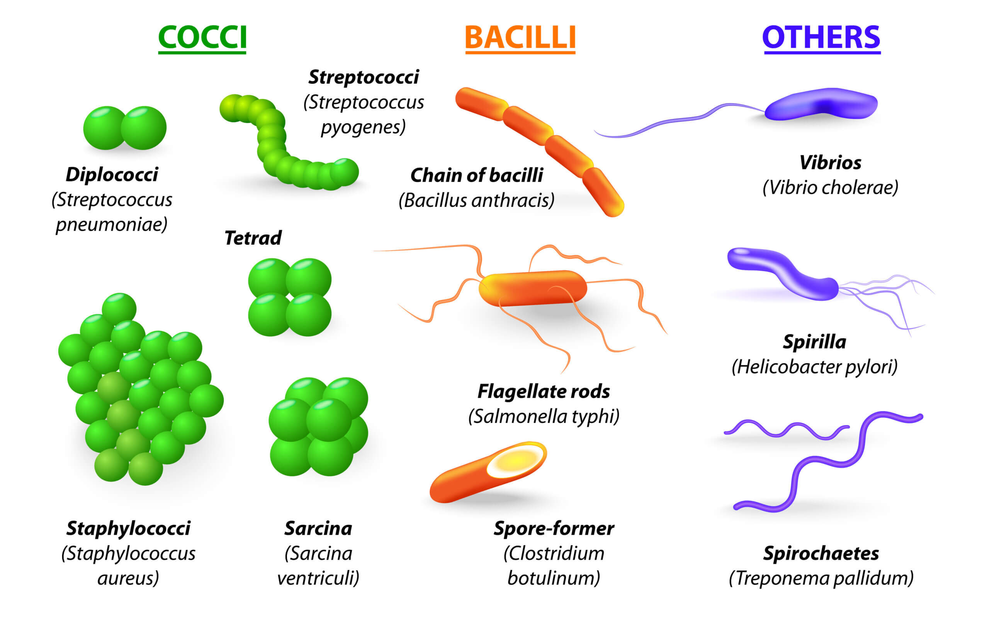

Plant Taxonomy.

Taxonomy is the oldest field of biological sciences. It deals with the study of the diversity of organisms and their classification. According to established criteria, the first attempts to organize the plant world were initiated in ancient times. Back then, plants were divided into groups based solely on their external similarities. Nowadays, the kinship of these organisms is increasingly taken into account.

