Overpopulated World.

As the population, or the number of people in the world, continues to grow, there is an increasing need for more homes. Many regions on Earth suffer from overpopulation. One in four people in the world lives in an urban area. Cities are systematically expanding, creating metropolitan areas. Some cities and countries are more densely populated than others. France has the same population as the United Kingdom, but because it occupies a larger territory, it is much less overpopulated. In other words, the population density there is lower than in the United Kingdom. Population density is the average number of people per square kilometer of land area.

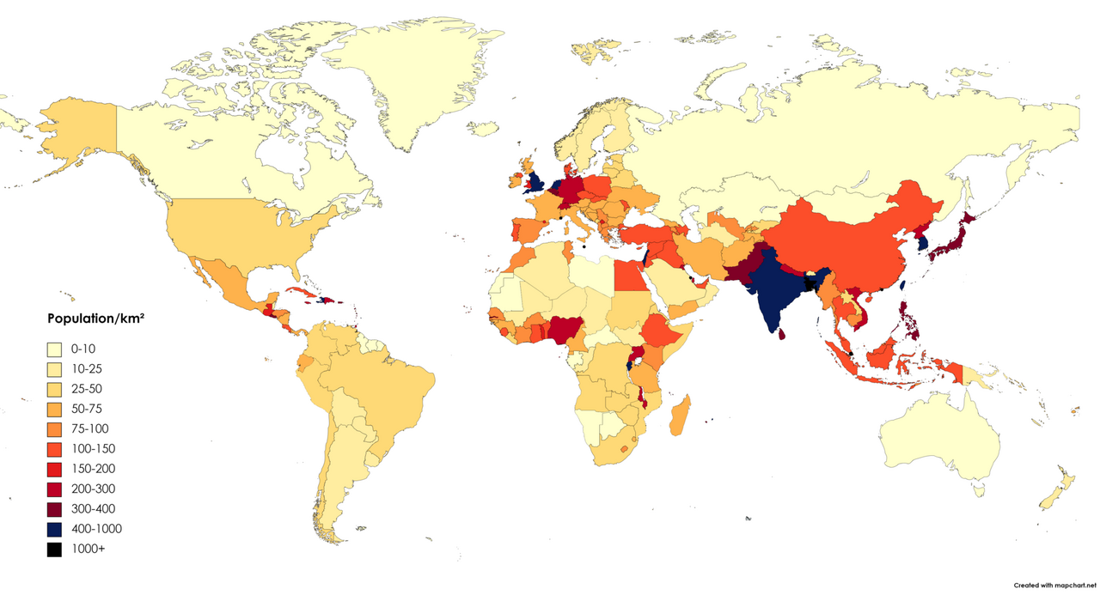

Population Density Diagram. Create a three-dimensional diagram illustrating population density. Prepare a long roll of Bristol board, a sheet of Bristol board, a ruler, scissors, and paints. Use the above map or refer to an Atlas. Check the population density in the areas you have selected.

Choose a scale for the "indicators" from the roll, for example, 5 cm represents 100 people per square kilometer. Calculate the population density for each country and cut appropriately long pieces from the cardboard roll. Paint and label each indicator.

On the sheet of cardboard, draw horizontal lines and label them as shown in the adjacent picture. Make the first line at a height of about 20 cm from the bottom and fold the sheet at this point so it doesn’t tip over. Attach the indicators in the appropriate places.

