**Cultivated plants** are of great importance to humans. They are a vital component of our food, serve as feed for animals, and are a raw material for certain industries.

Rice is the most important cereal, forming the staple diet for the majority of the world's population.

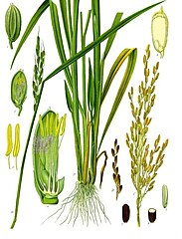

Hops are a climbing plant, and their cones are added to beer to give it a bitter taste.

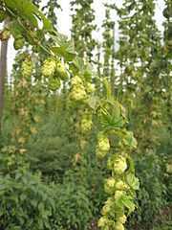

Onion is a tasty and valuable vegetable that should be present in every garden.

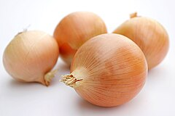

Tomato, due to its taste and nutritional value, is one of the most important cultivated plants in the world.

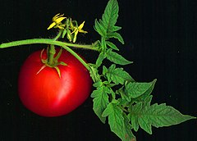

Wheat is the most important cereal grown in Poland, and wheat flour has the most uses.

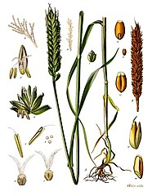

Rye flour is mainly used for baking bread, and Poland is a leading producer of this cereal worldwide.

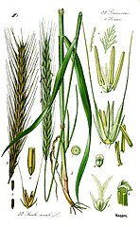

Cabbage, with its numerous varieties, is an essential ingredient in many traditional Polish dishes.

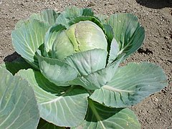

Date palm is often cultivated in desert areas, and its fruits are sweet and nutritious.

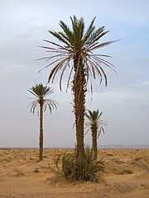

Coffee is an evergreen shrub or small tree, and its seeds are used to prepare the beverage after proper processing.

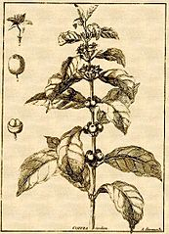

Rapeseed is a primary source of vegetable oils in Poland.

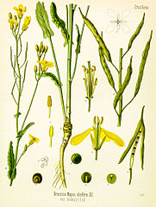

Corn can be consumed in various forms by people, but it is most often used as animal feed.

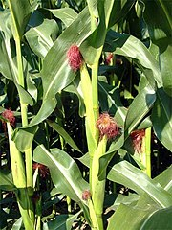

Sugar beets are usually grown on the best soils.

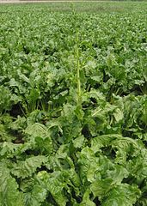

Orange trees are eagerly cultivated for their tasty, juicy fruits that are suitable for long-term transport.

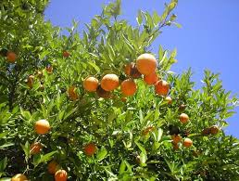

Sugarcane is a grass reaching up to 5 meters in height, with stalks filled with sweet pulp.

Banana plants flower and bear fruit only once in their lifetime, after which the entire plant dies.

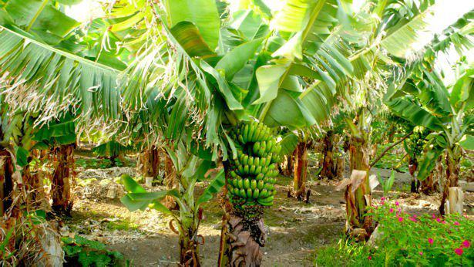

Olive trees produce aromatic, tasty, and very fat-rich fruits, from which olive oil is extracted.

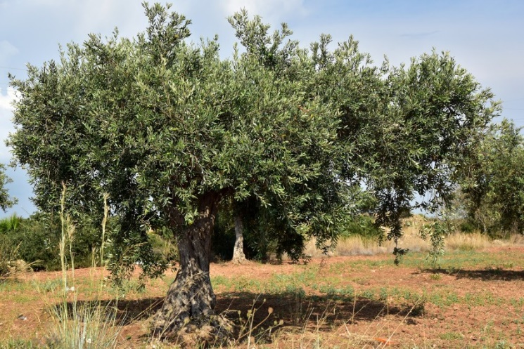

Strawberries grown in Poland are highly valued both domestically and abroad.

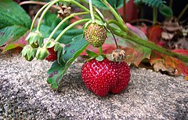

The soil and climatic conditions of Poland have made the potato a staple crop in the country.

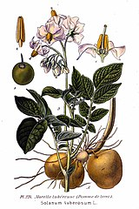

Apple trees produce the most commonly found fruits in Polish orchards.

