COMPETITION

* **PLANTS**

1. **Label the individual elements of the plant in the schematic drawing:**
   * stem, leaf, root, flower (4 points)

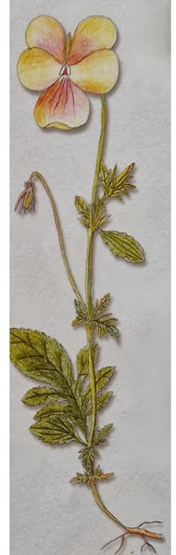

1. **Match the pine cone with the appropriate tree. (2 points):**

photo of a fir tree photo spruce cones

photo spruce photo fir cones photo larch cones

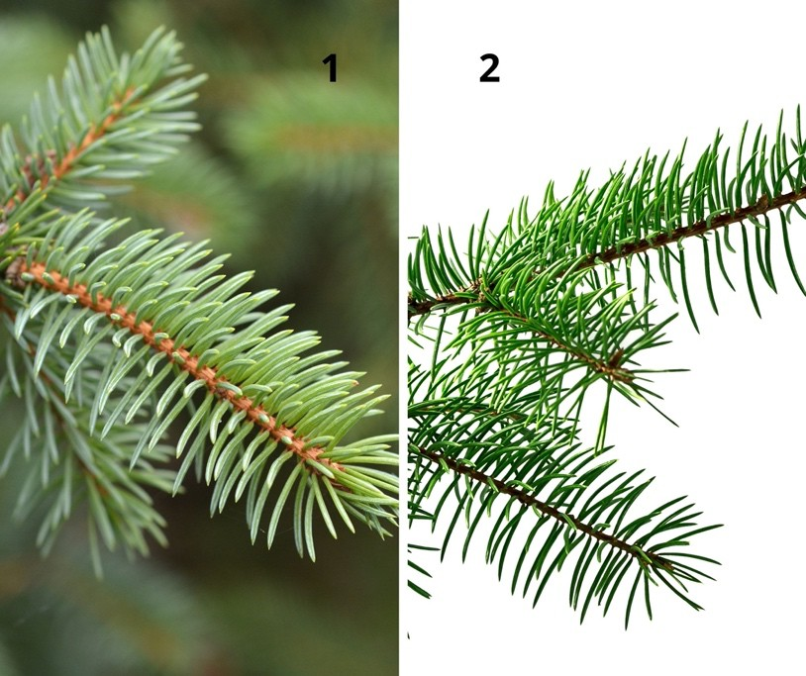

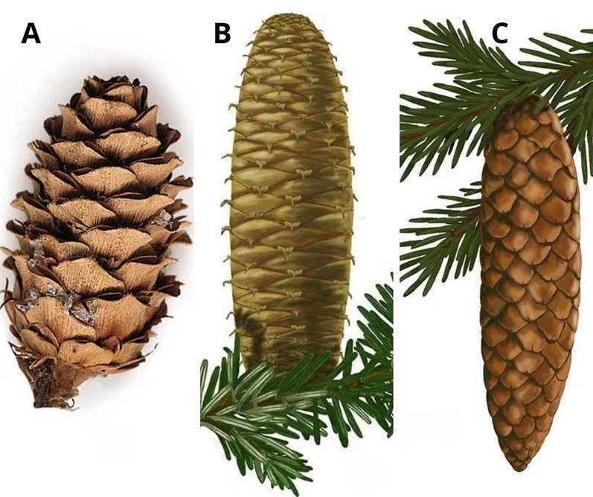

1. **Which plant is a herbaceous plant? (1 point)**
2. tricolor violet
3. wild elderberry
4. coral viburnum
5. **Give two examples of medicinal plants. (2 points)**

* …………………………………………………….
* …………………………………………………….

1. **Leaf structure – complete the diagram with the names:**
   * innervation, leaf blade, petiole (3 points)

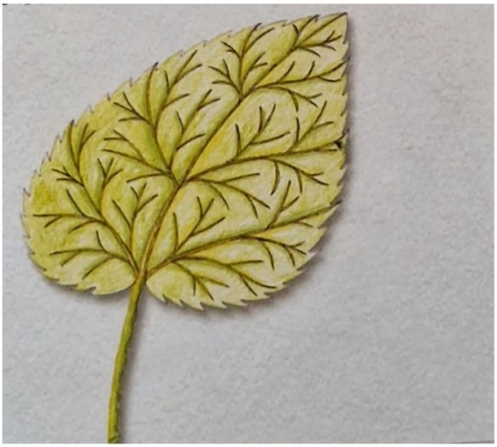

1. **Name three cultivated plants. (3 points):**

* …………………………………………………….
* …………………………………………………….
* …………………………………………………….

1. **Which coniferous tree loses its leaves in winter? (1 point)**
2. spruce
3. larch
4. pine
5. **Which plant does not fit here? (1 point)**
6. 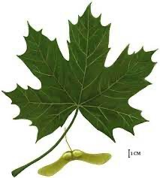clone
7. 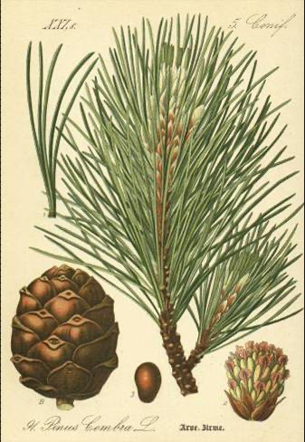limba
8. chestnut

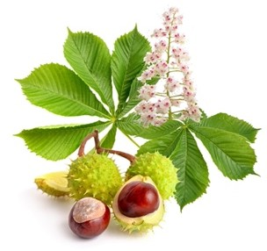

1. **Is a fern a spore-producing plant or a seed-producing plant?**

(1 point)

……………………………………………………

1. **Give two examples of ornamental potted plants.**(2 points)

* ……………………………………………………
* ……………………………………………………

1. **What are the functions of a plant root? Give two examples**. (2 points)

* ……………………………………………………
* ……………………………………………………

1. **Where mountain pine grows**? Underline the correct answer. (1 point)
2. in the mountains
3. in the dunes
4. in the highlands

* **ANIMALS**

1. **What is the difference between vertebrates and invertebrates?**(1 point)

……………………………………………………………………………………………………………………………… ……………………

……………………………………………………………………………………………………………………………… ……………………..

1. **Is a common frog a reptile or an amphibian?** (1 point)

……………………………………………………

1. **Match the names of the animals to their pictures** (4 points) pheasant

hawk mouflon

spotted salamander tapir

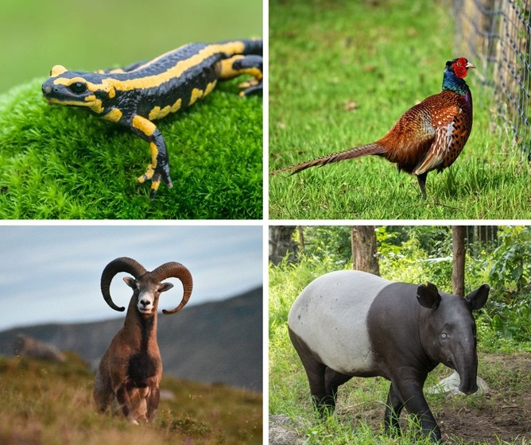

1. **Explain the concept of "species protection"**(1 point)

……………………………………………………………………………………………………………………………… ……………………

……………………………………………………………………………………………………………………………… ……………………..

1. **What is the body of birds covered with?**(1 point)

……………………………………………………………………………………………………………………………… ……………………

1. **Name two features of fish adaptation to the aquatic environment.**(2 points)
   * ……………………………………………………
   * ……………………………………………………
2. **Which animal is not a mammal?Underline the correct answer.** (1 point) bat stork squirrel
3. **Is reindeer a farm animal?** (1 point)

……………………………………………………

1. **What continent does the zebra live in?** (1 point)

……………………………………………………

1. **Name one function of a zoo.** (1 point)

……………………………………………………

1. **Which fish inhabits lakes? Underline the correct answer.**(1 point) cod crucian side
2. **Connect the animal to the landscape zone.** (3 points) Arctic giraffe

savanna deer

desert bear polar camel