The world has been divided into 6 zoogeographic realms based on the characteristics of the animal world in different areas. These realms are mainly defined by natural barriers that hinder or prevent the movement of animals.

The Antarctic realm is a vast area virtually devoid of terrestrial fauna. The few species that have adapted to the Antarctic cold are strongly associated with the sea.

The Emperor Penguin.

The Emperor Penguin is the largest of all penguins. Its body length can reach up to 150 cm.

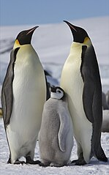

Mirunga (The Elephant Seal.)

The largest of seals is the elephant seal. An adult male can reach a length of up to 6.5 meters and weigh up to 3.5 tons.

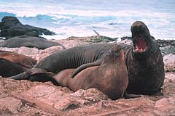

The Adélie Penguin.

The Adélie Penguin belongs to the species of birds most densely populated in Antarctica. Colonies of these penguins can number even hundreds of thousands of pairs.

Sea Lion.

The limbs of the sea lion have evolved into flippers, allowing them, along with other adaptations, to spend almost their entire lives in the water.

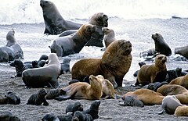

Killer whale.

The predatory killer whale hunts seals, sea lions and penguins in packs. It can attack its prey even on the shore.

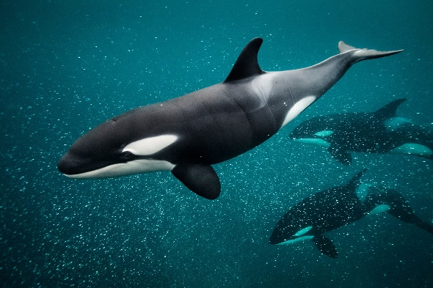

The Blue Whale.

The blue whale is the largest animal currently living on Earth. Its body length can reach up to 30 meters, and it can weigh up to 135 tons.

