Mammals are animals best adapted to life on Earth. They have mastered almost all environments. Many of the wild mammals encountered in Poland are endangered and subject to total or periodic protection. Humans also belong to mammals.

Bat.

Thanks to its highly developed sense of hearing, a bat can fly and hunt in the darkness.

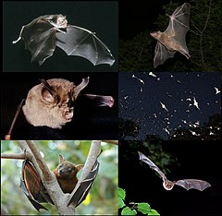

Deer.

The male deer has large, branched antlers called a crown, which it sheds every year. A female deer is called a hind.

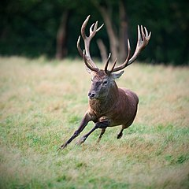

European bison.

The European bison is the largest mammal occurring in Poland. Currently, it can be found in the Białowieża Forest and in several other locations.

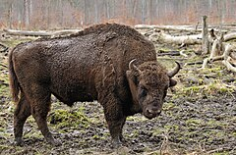

Beaver.

The beaver is the largest rodent occurring in Poland. It swims and dives well. It digs burrows and builds dams.

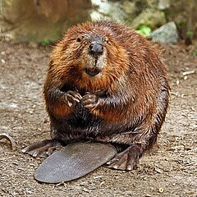

Wild boar.

The wild boar is the ancestor of the domestic pig; it eagerly consumes potato tubers and causes significant damage to the cultivation of this plant.

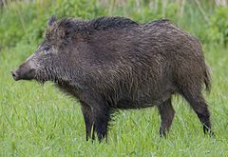

Hedgehog.

The hedgehog is a very common mammal that can be found on the edges of forests, in orchards, parks, shrubs, and gardens.

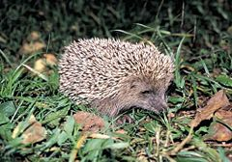

Weasel.

The weasel is the smallest carnivorous mammal living in Poland. It primarily feeds on small rodents, frogs, lizards, small birds, and their eggs.

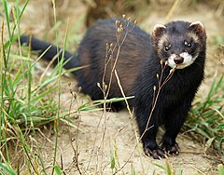

Squirrel.

The squirrel does not hibernate, so in the fall, it must gather supplies of seeds, nuts, dried fruits, and mushrooms.

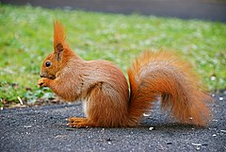

Brown bear.

The brown bear feeds on forest fruits, bird eggs, and occasionally attempts to catch fish, amphibians, birds, and even quite large mammals.

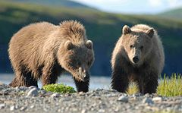

Fox.

The fox is a very intelligent and cunning mammal. Because it hunts domestic animals, it is often exterminated by humans.

Rat.

The rat is an exceptionally troublesome rodent because it spreads diseases and destroys grain. It is legally controlled in Poland.

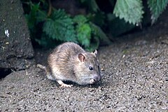

**Farm animals** are valued by humans.

They can work for us, provide us with food, or we keep them simply for our pleasure.

Horse.

The horse, due to its strength, is bred as a draft animal. The number of horses in Poland has been systematically decreasing for years.

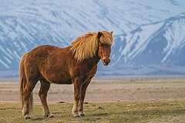

Cow.

The cow provides people with milk, meat, and leather. It is one of the most important farm animals.

Pig.

The pig is omnivorous, gains weight quickly, and is very fertile, which is why it is commonly bred for meat, skin, and fat.

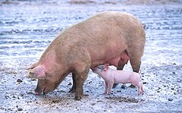

Chicken.

The chicken provides people with eggs and meat.

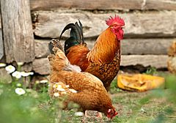

Canary.

The canary is most commonly bred for its beautiful plumage and voice.

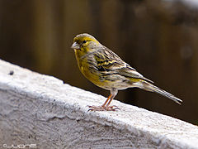

Carp.

The carp is the most important farmed fish, living in slow-flowing and still freshwater inland waters.

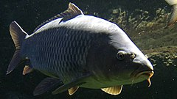

Pigeon.

The pigeon is a bird eagerly bred both in cities and in the countryside.

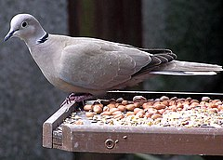

Bee.

The bee lives in large communities, where we distinguish the queen, workers, and drones. Humans use honey, wax, and other products made by these insects.

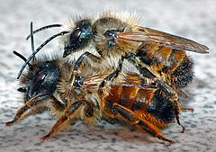

Dog.

The dog is probably the first domesticated mammal. Its excellent sense of smell, hearing, and loyalty to humans make it a good guide, rescuer, guard, and friend.

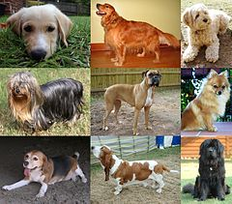

Rabbit.

The domestic rabbit originates from the wild rabbit. We know about 50 breeds of rabbits.

Cat.

In the past, the cat was valued as a rodent exterminator. Nowadays, many people keep it for pleasure.

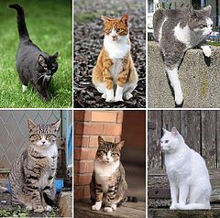

Hamster.

Raising a hamster is very easy, which is why many people have them.

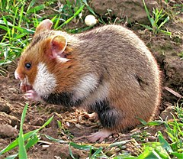

All over the world, animals are raised to obtain milk, down, wool, feathers, hair, eggs, meat, or hides from them. Additionally, some animals help humans with various physical tasks.

Dromedary Camel.

The dromedary camel is bred in North Africa and Southwest Asia as a pack and draft animal, and for its milk, wool, and hides.

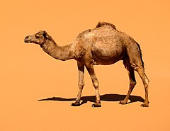

Sheep.

Sheep are raised worldwide for their valuable wool, milk, and meat.

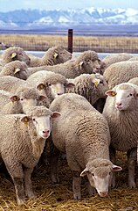

Crocodile.

Crocodiles are farmed in countries with hot climates for their meat and hides.

Llama.

The llama is bred in South America as a pack animal. Its wool and hides are also utilized.

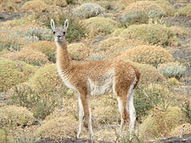

Yak.

The yak is a valued animal both as a pack and draft animal, living in Central Asia as both a wild and domesticated species.

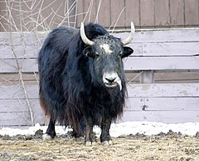

Goat.

The goat has low dietary requirements, making it particularly suitable for breeding in countries with sparse vegetation for its milk, meat, hides, and wool.

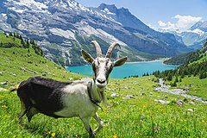

Indian Elephant.

The Indian elephant, though smaller than the African elephant, is very strong. It is used for heavy labor and transporting people and goods.

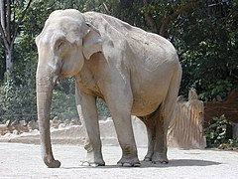

Quail.

The quail is the smallest domesticated bird whose eggs are consumed by humans.

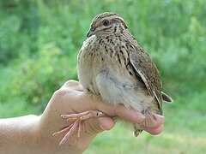

Donkey.

The donkey has low requirements and is very durable, which is why it is bred as a pack and draft animal in warm climates.

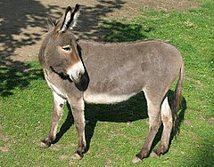

Reindeer.

The reindeer is used as a draft animal by people living in the far north and also provides milk, hides, and meat.

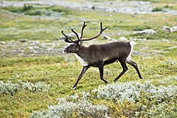

Turkey.

The turkey can reach a weight of up to 10 kg. It is bred for its meat, mainly in North and Central Africa.

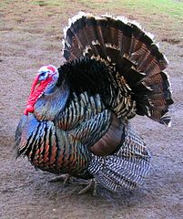

In Poland, many species of birds live, most of which are protected. Birds usually take care of their offspring. Some chicks require many days of care, while others are independent just a few minutes after hatching.

Long-eared Owl.

Among nocturnal birds, the long-eared owl is the best known because it allows itself to be observed from short distances.

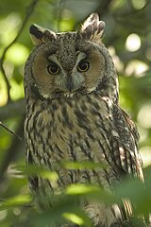

Hawk.

The hawk is a predator that hunts birds and small mammals. Unfortunately, it is now relatively rare in Poland.

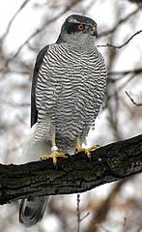

Black-headed Gull.

The black-headed gull is increasingly common in Poland. It is found both near all types of water bodies and at garbage dumps.

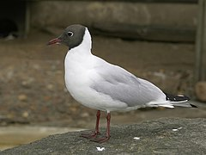

White-tailed Eagle.

The white-tailed eagle is a large predator that mainly hunts fish. It is rarely seen and generally lives in the forests of northern and western Poland.

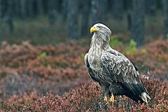

White Stork.

The white stork is well-known and loved in Poland, and it is under special protection. Most of the world's white storks live in Poland, building nests on poles, roofs, and chimneys.

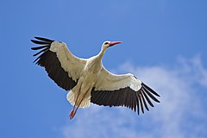

Woodpecker.

The woodpecker obtains food by pecking holes in the bark and trunks of trees to reach hidden insects.

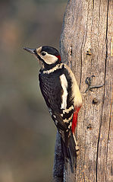

Crow.

The omnivorous crow is increasingly common in suburban areas.

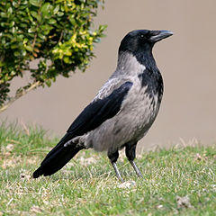

Rook.

The rook arrives in Poland in the fall and returns to its nests in northern and eastern Europe in the spring.

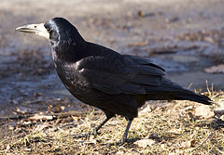

Swallow.

The swallow builds nests out of mud and its own saliva. It prefers to live under the eaves of rural houses and farm buildings.

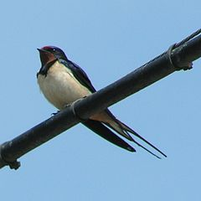

Pheasant.

The pheasant was introduced to Poland only a few hundred years ago, but it is now a common inhabitant of fields, meadows, and wastelands.

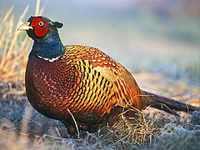

Sparrow.

The sparrow has become an inseparable companion of humans. We can find this bird both in cities and in the countryside.

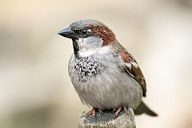

Cuckoo.

The cuckoo is distinguished by its unusual way of handling its eggs. It lays them in the nests of other birds, which then incubate and feed the cuckoo chicks.

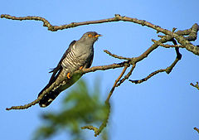

**Amphibians of Poland.**

Almost all amphibians living in Poland are protected. One of the few exceptions is the common frog, but it also deserves protection. River regulation, draining of marshes and wetlands, as well as drying out of damp meadows, threaten the survival of most amphibians found here.

Common Toad.

The common toad is very useful as it preys on pests in our fields and gardens. When threatened, it puffs itself up to scare off the attacker.

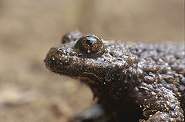

Fire Salamander.

The fire salamander usually lives in low forested areas of the mountains, and its skin contains a fairly strong poison, secreted only in threatening situations.

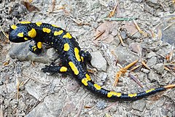

Common Frog.

The common frog spends almost its entire life in stagnant waters during the mating season. The male emits a characteristic croaking sound.

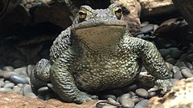

Common Grass Frog.

The common grass frog mainly lives in forests, gardens, and meadows, but during the mating season in spring, it migrates to a chosen body of water to lay its spawn.

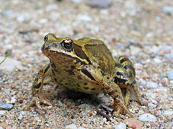

Northern Crested Newt.

The northern crested newt is the largest newt living in Poland. The characteristic crest on its back appears only in males during the mating season.

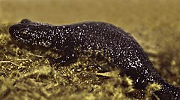

**Reptiles of Poland.**

All reptiles in Poland are protected. For many years, people were afraid of snakes, so they killed them, and today there are few reptiles in Poland. The only venomous snake in Poland is the European adder; there is no need to fear other reptiles.

Slowworm.

The slowworm is a lizard whose legs have almost disappeared and are not visible. Therefore, it can be mistaken for a snake.

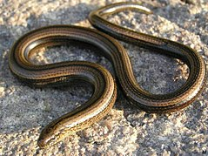

European Legless Lizard.

The European legless lizard is very aggressive, it suffocates its prey by wrapping around them, it is not venomous, and does not pose a threat to humans.

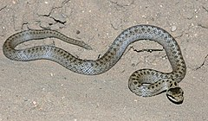

Common Lizard.

The common lizard is the most frequently encountered reptile in Poland.

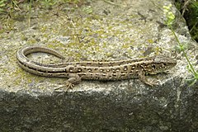

Grass Snake.

The grass snake is a common snake in Poland. It hunts small animals, mainly aquatic ones, and is completely harmless to humans.

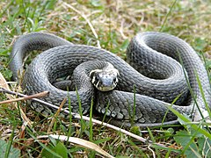

European Adder.

The European adder is the only venomous snake living in Poland. Its bite can be deadly. Medical assistance is necessary.

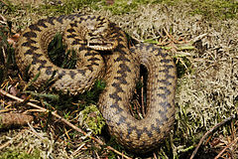

Viviparous Lizard.

The viviparous lizard, like other reptiles, reproduces by eggs. However, these eggs remain inside the female's body until the young hatch.

