**The Australian Region** includes Australia, New Guinea, and Tasmania. Due to its long isolation from other continents, many endemic families have developed in this region. A characteristic feature of Australian fauna is the almost complete absence of placental mammals. The mainstay of the native fauna consists of marsupials. The most primitive living mammals, monotremes, are also found there.

Hedgehog. The hedgehog is one of the most primitive mammals. Its young hatch from eggs and then feed on their mother's milk for a period of time.

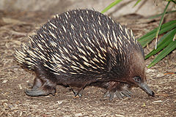

Tasmanian Devil. The Tasmanian devil is the largest living marsupial carnivore.

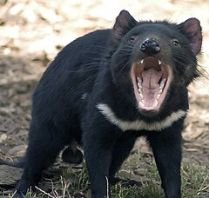

Cockatoo. The cockatoo parrot is large, beautiful, easily tamed, and willingly repeats a few learned words.

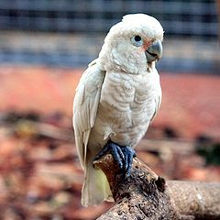

Platypus. The platypus is considered one of the strangest animals on Earth. It swims in water like a fish or a seal, lays eggs like a reptile or bird, yet it is a mammal.

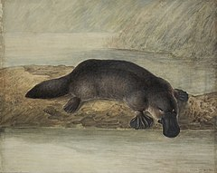

Possum. Among Australian marsupials, the possum has adapted best to human presence. It can be found in parks, backyard gardens, and even on rubbish dumps.

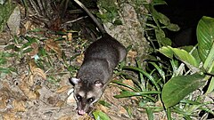

Kangaroo. The kangaroo is an Australian marsupial. It moves skillfully on two legs, aided by its strong tail.

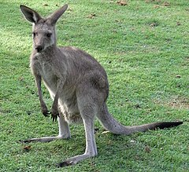

Emu. The emu runs superbly, but its feather and wing structure prevents it from flying.

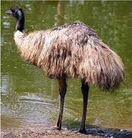

Koala. The koala bear has nothing in common with bears. It lives in trees, feeds exclusively on eucalyptus leaves, and almost never drinks water.

