**The Neotropical** Region comprises South America, Central America, and Southern Mexico. Due to the long isolation of this area, there are many endemic families here. Some animal groups are similar to those living in Africa and Australia, which confirms the theory of the connection of these continents in ancient geological epochs.

Toucan's beak looks massive, but it's very lightweight and equipped with small teeth on the edges.

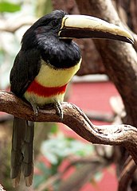

Capuchin Monkey. The capuchin monkey is a resident of hot regions in South and Central America, easily adapting to humans.

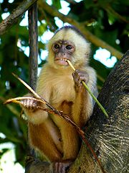

Sloth. The sloth is a very slow animal, spending most of its time hanging upside down from branches with powerful claws.

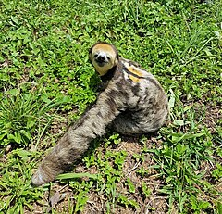

Capybara. The capybara is the largest rodent on Earth, usually found in humid areas. It swims and dives well.

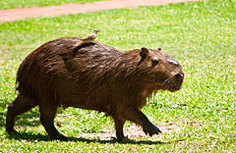

Armadillo. The armadillo is a mammal with a back covered in bony plates. In danger, it curls up into a ball.

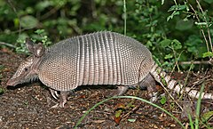

Condor. The condor is a giant scavenger bird living in the mountains of both Americas. It nests on inaccessible rocky ledges.

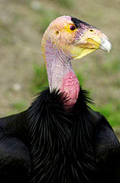

The American tapir, the American tapir, is large, gentle, and timid, inhabiting marshy areas.

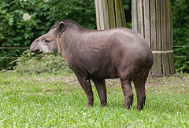

Anteater. The anteater digs into anthills or termite mounds with its huge claws and catches insects with its long, sticky tongue.

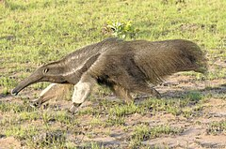

Jaguar. The jaguar is dangerous even to large animals because it runs very fast, swims well, and climbs trees adeptly.

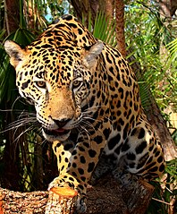

**The Palearctic Region** is the largest region covering Northern Europe, North Africa, and Asia, except for southern China and India. Its individual regions differ from each other. There are few animal families characteristic only of the Palearctic. Most animals belong to families that also occur in other countries. Poland is also located in this region.

Panda. Pandas can only be found in the wild in China. This beautiful animal is facing total extinction.



Polar Bear. Polar bears can weigh up to 700 kg. Despite their size, they can run fast, swim excellently, and dive.

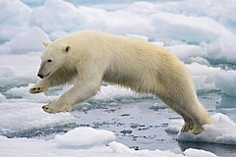

Mouflon. Mouflons inhabit mountain forests and are closely related to domestic sheep.

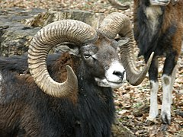

Bactrian Camel. The Bactrian camel is found in the wild in the Gobi Desert. It is bred in Central Asia.

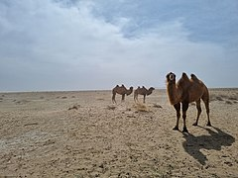

Lynx. Lynxes inhabit large, dense forests, climb trees well, and hunt by pouncing on their prey.

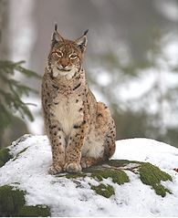

Wolf. Wolves live in packs, hunt large mammals, but also eat eggs, even those with defects.

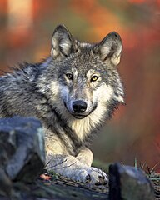

Elk. Elks inhabit forested and marshy areas, feeding on green plants and tree bark.

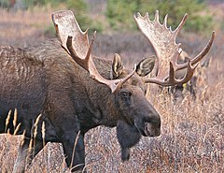

Swan. Swans are beautiful, large birds mainly feeding on aquatic vegetation.

