**The Nearctic Region** encompasses North America up to central Mexico. In this area, counterparts of Palaearctic species are found, although they differ slightly from them. The bison is the counterpart of the European bison, the mountain goat is the counterpart of the chamois, and the grizzly bear is the counterpart of the brown bear.

Rattlesnake. The rattlesnake is a venomous snake with a rattling appendage at the end of its tail in the form of a rattle. When it moves its tail, the rattle emits a characteristic sound that deters animals.

Puma. The puma is a large predator that hunts mammals and birds at night.

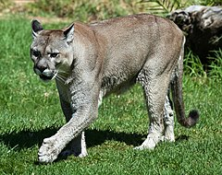

Coyote. The coyote, a predator related to the wolf, hunts rodents, amphibians, and small animals. It resembles a jackal in appearance.

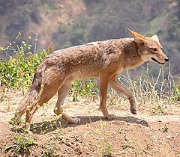

Raccoon. Raccoons feed on frogs, fish, crayfish, as well as nuts and other fruits. Before eating, they thoroughly wash each food item in water.

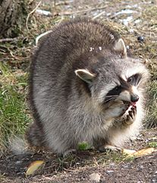

Bison. The bison is a herbivorous mammal inhabiting North America. It is related to the European bison.

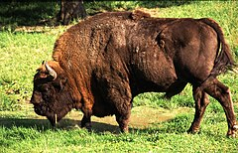

Skunk. Skunks are sometimes called "stinkers" because, in danger, they can spray a non-smelling liquid at a distance of several meters.

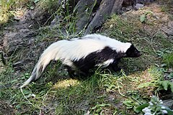

Grizzly Bear. The grizzly bear is one of the largest land predators. It prefers to feed on fish but also consumes plants.

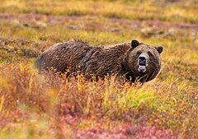

Muskox. The muskox, inhabiting the Arctic tundra, feeds on grasses, lichens, and mosses.

