**The Oriental Region** comprises Southeast Asia and nearby islands lying in the tropical zone. The fauna of this region is very rich and similar to the Ethiopian Region. Many animal groups are represented equally in both regions, but by different species.

Komodo Dragon. These lizards, also known as Komodo dragons, reach lengths of up to 3 meters and weigh over 130 kg. They are predators that hunt even large mammals.

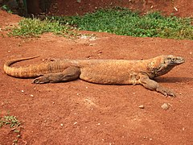

Bengal Tiger. The Bengal tiger is currently very rarely encountered, although originally it inhabited almost the entire southern Asia.

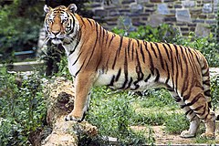

Cobra. The cobra is a highly venomous snake. When threatened, it raises the front part of its body and spreads its skin folds, revealing an image that resembles the frightening eyes of a large animal.

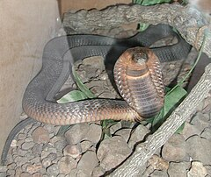

Orangutan. The orangutan is the largest ape living in Asia.

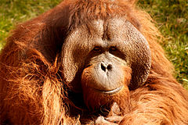

Malayan Tapir. The upper lip of the Malayan tapir is fused with its nose, creating something similar to a very short trunk.

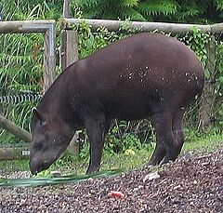

Indian Buffalo. Indian buffaloes live exclusively near water. The weight of one individual can reach up to 1000 kg, and its characteristic feature is huge, crescent-shaped horns.

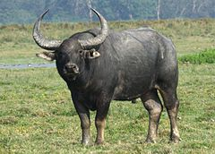

Indian Rhinoceros. Indian rhinoceroses have survived only in reserves. They have only one horn and heavily calloused skin, which is why they are sometimes called armored rhinoceroses.

