The Ethiopian Regio

n encompasses Africa, excluding parts of North Africa and the southern Arabian Peninsula. The nature of Africa is rich and diverse, hosting the world's greatest diversity of animals. Off the coast of Africa lies Madagascar, which due to its many differences is sometimes treated as a separate entity.

Hyena, has the strongest teeth among mammals, it attacks its prey at night, and also eagerly feeds on carrion.

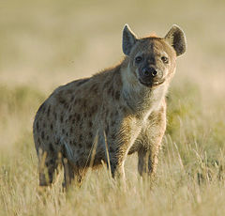

The African ostrich is the largest flightless bird in the world, it runs well and fast.

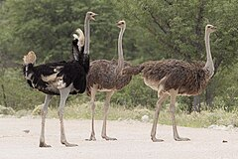

Crocodiles live in rivers, lakes, and swamps.

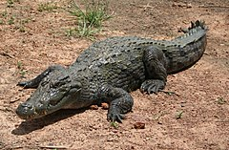

The lion is the largest cat in the world and a formidable predator.

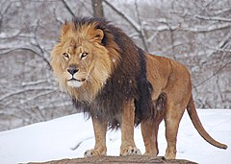

The chimpanzee is a hominid that walks in an upright posture, it is the largest hominid.

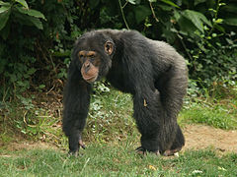

Gorillas live in small groups, where the strongest male dominates.

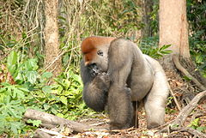

Giraffe, a mammal with the longest neck, allowing it to graze on the leaves of tall trees.

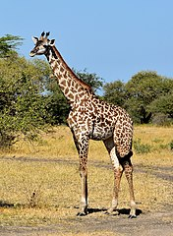

Chameleon, a lizard that mainly lives in trees, its body coloration can change.

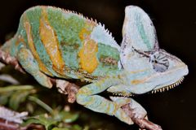

The African elephant is the largest land mammal, it was massively killed by poachers due to its valuable tusks.

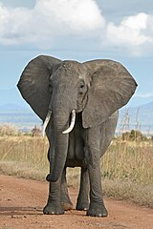

Zebra is a herbivorous mammal related to the horse.

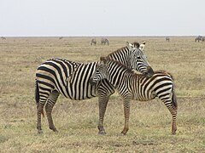

Agama, a popular lizard in the Ethiopian region, found both on rocks in the forest and on the walls of houses.

