Complete the diagram
Fill in each field with two examples
Landscape features

Advantages | Big cities  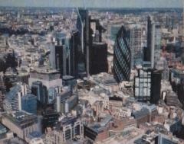 | Disadvantages

