Fish anatomy and adaptations to life in water.

Most fish have elongated bodies with a streamlined shape. They are covered with skin, which is densely populated with scales. Thanks to a thick layer of mucus, their skin is smooth and slippery. Fish swim using undulating movements of their fins and tail, which provide the main source of propulsion. A characteristic feature of their anatomy is the presence of fins. We distinguish between paired fins: pectoral and pelvic fins, and unpaired fins: dorsal, caudal, and anal fins.

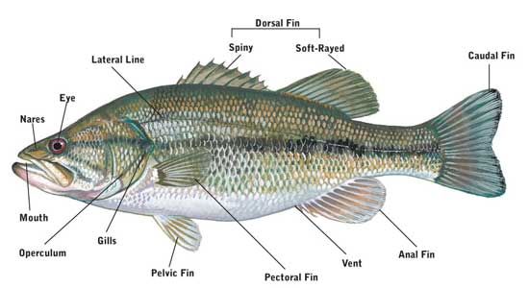

How do fish breathe?

Fish breathe through gills. They are bathed in water, which provides oxygen and removes carbon dioxide. Then, the water exits through the gill slits, which are hidden under opercula. Fish gills consist of delicate, thin filaments intertwined with a dense network of capillaries.

