Great cities of Europe - Paris and London.
Lesson objectives: you will get to know the largest cities in the world and Europe, learn to describe the characteristics of the landscape of big cities, understand the advantages and disadvantages of big cities, and find out about the tourist attractions of Paris and London.
To get started, during the geography lesson, students analyzed charts showing the population numbers in the largest cities of Europe and the world. Write down the names of the students who formulated correct conclusions based on the charts below.
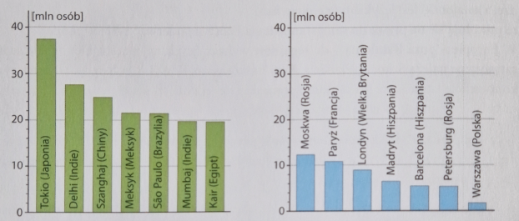

Zosia: The largest city in the Western Hemisphere is Mexico City.
Marcin: The 3 largest cities in the world are located in Europe.
Krzysiek: The largest city in Europe is London.
Tomek: The difference between the population of London and Tokyo is about 28 million people.
Ania: Paris has six times more population than Warsaw.

Children's names………………………………………………………………………………………………………………………….

