Coat of arms of voivodeships (1)
Arrange the names of voivodeships, whose coats of arms are shown on the left side, from the scattered letters.
Mark those voivodeships on the map with appropriate numbers.
Finally, complete the saying of the Wawel Dragon.
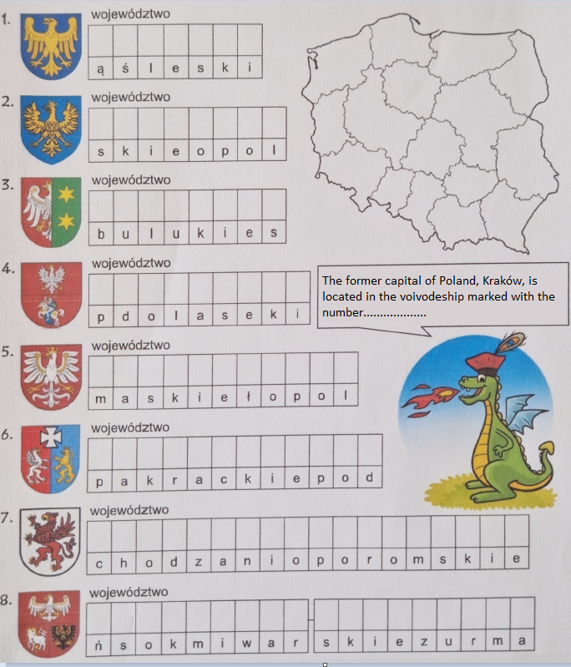

The coat of arms of voivodeships (2)
Arrange the names of voivodeships, whose coats of arms are shown on the left side, from the scattered letters.
Mark those voivodeships on the map with appropriate numbers.
Finally, complete the saying of the Warsaw Mermaid.
