Leaves remain on trees for 2-3 years and do not all fall at the same time. That's why the tropical rainforest is evergreen.
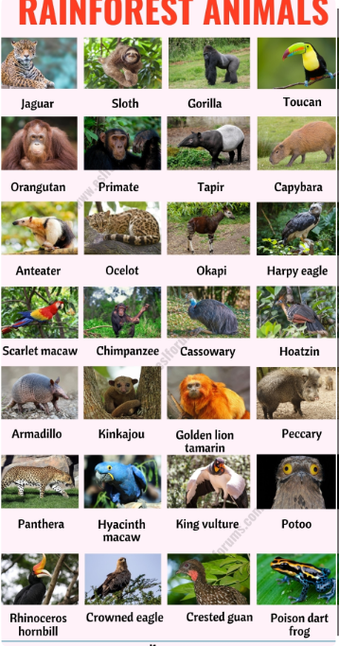
The Amazon forests provide shelter for numerous animals, some of which, like sloths or armadillos, cannot be found anywhere else. Dozens of species of colorful birds, such as parrots, also live here. Water vapor rises, cools, and condenses. This creates clouds, from which heavy rains fall every afternoon for 2-3 hours. They are called zenith rains. The high amount of rainfall and the high air temperature persist throughout the year, so there are no seasons in the zone of humid equatorial forests.

The world of plants and animals in equatorial forests.
Favorable climatic conditions cause vegetation to thrive and form evergreen leafy forests called humid equatorial forests. In the plants of humid equatorial forests, several layers are formed, with the tree layer reaching a height of 30-40 meters. It is so dense that there is semi-darkness below it, and plants from the lower layers must compete for access to light. The most numerous group of animals in humid equatorial forests are insects. Many animals, such as monkeys and various birds, spend their lives in the tree crowns. On the forest floor, large mammals such as tapirs and jaguars can be found.
Layers of the humid equatorial forest.
In a humid equatorial forest like the Amazon Rainforest, there are several layers of vegetation, and a huge number of animal species live in them.
