**Traditional energy source based on fossil fuels apart from wood.**

**Wood.**

The first significant source of energy in the early period of industrialization. Currently used in many regions of the world for cooking food and heating homes.

Southern Africa, Asia, South America.

**Coal.**

The main energy resource from the second half of the nineteenth century to the second half of the twentieth century.

Coal is used as fuel for thermal power plants, as well as for coke production necessary in steelmaking and in the chemical industry, including the production of coal tar gas and benzol.

Coal reserves are estimated at around 800 billion tons.

The largest producers are China, the USA, India, Australia, Indonesia, South Africa, Russia, and Poland.

The largest importers are Japan, Korea, Taiwan, Germany, the Netherlands, the United Kingdom, and Italy.

The largest exporters are Australia, South Africa, the USA, Canada, Indonesia, Poland, China, and Colombia.

The most important coal mining areas in the world:

Europe - Poland, Germany, the United Kingdom, Russia.

Asia - China, India, Russia, Kazakhstan.

**Alternative renewable energy sources.**

Solar energy.

Used on a large scale in regions with high sun exposure. In areas with weak sunlight, solar energy is used on a local scale.

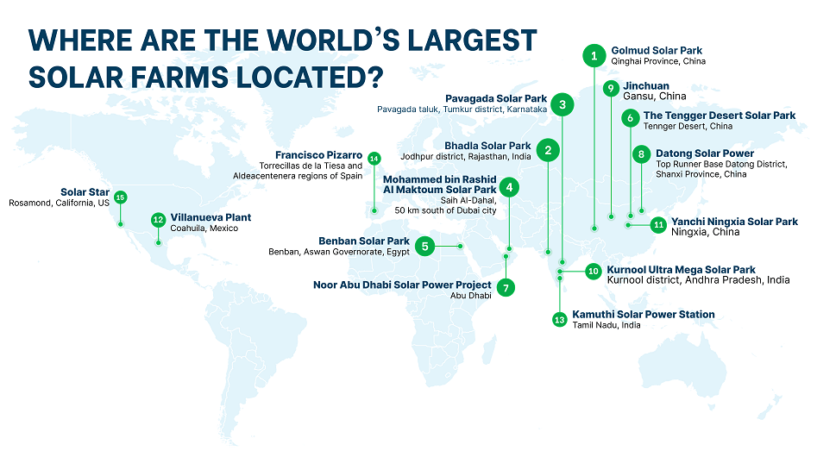

Wind energy.

Turbines powered by wind. The biggest issue is dependence on weather conditions and variability of wind strength. Wind turbines generate a lot of noise. Vibrations must be located away from human settlements.