Hydropower
- A very cheap source of energy, but the construction of dams and hydroelectric power plants is expensive.
- It develops in mountainous countries where rivers have great power.
- In Norway, 99% of the produced energy comes from hydroelectric power plants.
- In Siberia, on the great Siberian rivers.

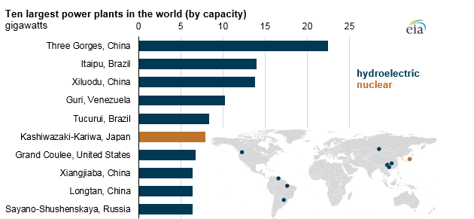

Tidal energy.

- It utilizes the differences in sea level during high and low tides.
- During high tides in straits, bays, and river estuaries, the water level rises even by several meters. In the mouth of a river, there is a dam that holds back the water during high tide.
- During low tide, the accumulated water is released and moves the turbines of the power plant.

The largest tidal power plants in the world.
