Geothermal power plant (also known as a geoelectric power plant) - a type of power plant that generates electricity from geothermal energy (heat from within the Earth). Geothermal power plants operate in many countries around the world and achieve an efficiency of approximately 25%. The largest ones are:
The Geysers Fields in the USA (908 MW)
Larderello in Italy (420 MW)
Wairakei Power Station in New Zealand (293 MW)

Geothermal energy (also known as geothermal power or geothermics) - thermal energy from rocks, water, and the ground beneath the Earth's surface, classified as a renewable energy source. However, the process of renewing geothermal sources is slow, so with a small flow of geothermal heat, extracting a large amount of heat can lead to cooling of rocks or a decrease in pressure in the reservoir. Geothermal energy is accessed through wells similar in technology to oil wells, but differing in details of execution and location. Geothermal energy can be extracted using ground-source heat pumps or deeper wells, which are usually used to exploit deep aquifers with hot water. Alternatively, it is possible to utilize the thermal energy of impermeable or poorly watered rocks, into which cold water is injected and then hot water is extracted after heating. One manifestation of the presence of geothermal energy is thermal springs.
Geothermal energy is utilized in 64 countries, and the total capacity of operating geothermal power plants is 11.4 GW (2012). It is the most significant source of energy in Iceland and the Philippines. In the European Union, geothermal energy accounts for 0.84% of primary energy production. In Poland, geothermal installations providing heat to the district heating system operate in six locations, including the Podhale region, and account for 0.03% of primary energy production.
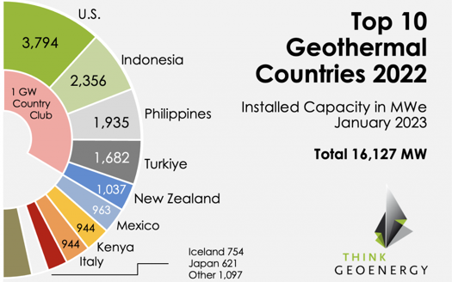
Availability of geothermal energy
The temperature of the Earth increases with depth, reaching 6600°C in the core. Approximately 20% of the Earth's internal heat energy comes from gravitational contraction during the planet's formation, while the remaining 80% comes from the decay of radioactive isotopes of potassium (40K), uranium (238U and 235U), and thorium (232Th), which occurs in the mantle. The friction caused by tidal forces and changes in the Earth's rotation speed also contribute to the thermal energy of the Earth's crust. Some of the thermal energy from the core is transported to the Earth's crust through mantle plumes, which can lead to the formation of hotspots and volcanic eruptions.
Geothermal energy naturally escapes to the Earth's surface with a power of about 46 TW. The average geothermal flux is about 0.063 W/m² – it is not very large, but the resources of this energy are practically inexhaustible due to the enormous volume of the Earth. This flux gives an average temperature gradient (increase towards the center) of 25 K/km. This is insufficient for direct exploitation, so-called hyperthermal regions (gradient greater than 80 K/km) and semithermal regions (from 40 to 80 K/km) are important in geothermal energy. Hyperthermal regions mainly include radiogenic areas (high content of radioactive elements), areas of high heat flux (rocks with very high thermal conductivity), and point heat sources (magma resources, geothermal waters). In these regions, geothermal resources occur as petrothermal (energy stored in rocks) and hydrothermal (in water).
Energy extraction
The main method of extracting geothermal energy is to drill wells into hot geothermal water reservoirs. At a certain distance from the extraction well, a second well is drilled, through which geothermal water, after transferring its heat, is injected back into the reservoir. Geothermal waters are usually highly saline, which poses particularly challenging working conditions for heat exchangers and other components of geothermal installations. Geothermal energy is used in central heating systems as the primary source of heat energy. Another application of geothermal energy is electricity generation. This is profitable only in the case of particularly hot sources. The threat posed by geothermal energy production includes pollution of groundwater, release of radon, hydrogen sulfide, and other gases.
Hot springs, known as geysers, are a characteristic feature of Iceland's landscape, where they are utilized as a source of heating and hot water. This does not have a negative impact on the natural environment.

Biomass energy
- used on a small scale
- biomass is utilized, e.g., manure, straw, biogas, energy crops
- mainly in Asia

