Electricity production.
Electricity is produced in various types of power plants: thermal, hydro, nuclear, solar, wind, and geothermal. Renewable and non-renewable energy sources available in a given area are utilized in this process.
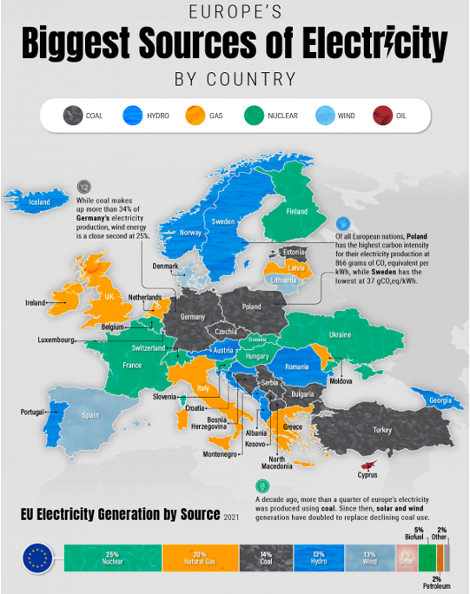

Electricity production in the world
