Glaciers.
A mountain glacier, also known as an alpine glacier, moves slowly downhill under its own weight. It forms from snow accumulating in cirques and gradually changing into ice. Cirques are deepened by frost cracking and abrasion, leading to the formation of steep ridges between adjacent cirques. When the accumulation of ice in the cirques reaches a certain level, the glacier moves down the slope. As the glacier advances, it transports rock fragments ranging from small pieces to giant boulders. Rocks embedded in the glacier's base erode the mountain valley, giving it a U-shaped profile. Under the glacier, erosional features such as roches moutonnées (hard rock knobs) and drumlins (rounded hills of glacial till) are formed. The glacier terminates at its snout, where the ice melting process occurs at the same rate as ice supply. An increase in temperature accelerates ice melting and glacier retreat. A retreating glacier leaves behind moraines and erratics. Streams from the melting glacier waters create eskers and kames. They also carry finer sediment fractions onto the foreland, forming plains. Ice blocks carried onto the foreland and covered by sediment eventually melt, forming glacial lakes.

mountain glacier
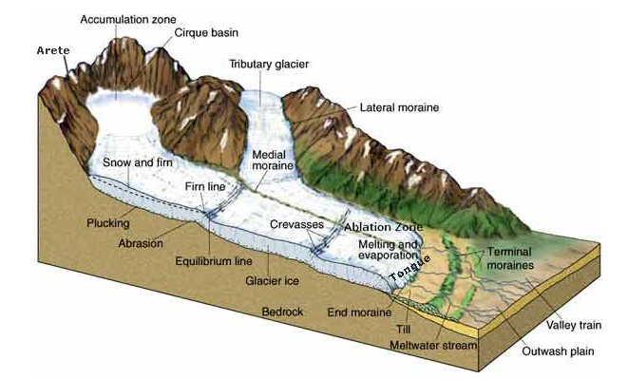

glacial valley
