At the end of the Ice Age and the opening of new lands, fauna (animal life) began on the Scandinavian Peninsula. Among the early animals were wild reindeer, accompanied by predators such as bears, wolves, wolverines, and Arctic foxes. A large number of moose, deer, wild boar, marten, foxes, beavers, otters, squirrels, hares followed later.
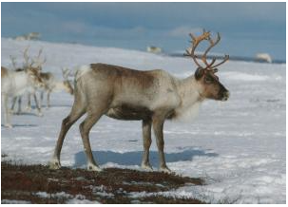
Reindeer can now only be seen in a few places on Earth.

Animal Adaptation
Reindeer and moose herds were particularly important as they provided a food source for predators. The wilderness disappeared from the hostile environment shortly. Over time, some species of Norwegian animals and birds developed camouflage by coloring or protecting themselves to improve the quality of their hunts. Today, about 15,000 to 20,000 wild reindeer still survive in Norway. Polar bears may still be found in the Svalbard archipelago. Other predators such as wolves, wolverines, and lynx have now disappeared.

Remaining species
Without these predators, moose herds are significantly increasing. Other species of animals include various rats and small rodents. The most noticeable rodent is the small, fluffy lemming. Norway is also home to many birds, including crows, eagles, grouse, partridges, owls, woodpeckers, cranes, swans, coots, geese, and ducks. Millions of cliffs and coastal areas are occupied by cormorants, gulls, and colorful puffins.

Birds and marine animals
Norway was once home to flightless birds that are now extinct. Today, the sea eagle, the most spectacular of all Norwegian birds, is listed as an endangered species. The government has made significant efforts to restore the sea eagle population. Marine life constitutes a significant portion of Norway's fauna. Coastal areas are home to a huge diversity of marine life, ranging from whales and seals to fish species such as cod, halibut, and mackerel. There are also shrimp and many other crustaceans. Norwegian rivers are full of freshwater fish such as salmon, trout, perch, and pike.

