The structure and adaptation of birds to flight.
Birds' bodies are lightweight and streamlined. They are covered with thin and dry skin from which feathers grow. The forelimbs of birds are transformed into wings. The hind limbs enable movement on land and in water, and in some birds, they serve additional functions. For example, they allow for grasping prey or perching on tree branches.
Bird Wings.
Bird wings are largely adapted to fit a bird’s hunting style. Long wings that end in a point work well for gliding birds such as gulls. This shape facilitates hovering, turning, and diving into the water for food. These skills are helpful for sea-dwelling birds, since they must circle bodies of wa ter to spot fish and then dive down to the water to catch them. Some birds such as vul tures and osprey have finger-like feathers at the end of their wings, which help the bird make small changes while gliding. Birds with this wing shape can stay high in the air for a long time and soar with little or no flapping while they look for food. This allows the bird to use as lit tle energy as possible in its search for food. Ducks, herons, and many migratory birds have pointed wings that appear to bend backwards. These wings make it more difficult to take off from the ground, and once in the air the birds must flap their wings quickly to stay in flight. The advantage of this wing type is that it al lows birds to fly long distances. Since fly ing long distances is the main priority for migratory birds, this wing shape is well suited for them. Short and wide wings allow birds suchas pheasants to take off from the ground quickly, but they are unfavorable for long distance flying. Since birds with this wing type spend much of their time on the ground, it is more useful for them to be able to take off quickly than to stay in the air for an extended period of time.
Beaks and Feet.
The charts on this sign display the most common types of bird beaks and feet. Each species of bird has a beak adapted to the type of food they eat. For instance, birds that eat seeds and nuts have short, tough beaks that make it easy to crack through hard shells. Specially adapted beaks for each species make finding and eating food much easier. Bird feet are adapted to the type of habitat that the bird lives in. Ducks have webbed feet since most of their time is spent in the water. Birds that spend most of their lives in trees have longer toes in order to grasp on to branches. Different foot types allow birds to comfortably live in their habitats. On display is a pair of mallard ducks and a wood duck. Both of these species depend on bodies of water for both food and habitat. As a result, their beaks are designed to strain food out of the water and their feet are designed to help them swim. Wood ducks also perch in trees so their feet have sharp claws to grasp tree branches.
Common Bird Characteristics.
Despite the many differences between species, all birds share several characteristics. All birds are warm-blooded and lay hard-shelled eggs. They all have backbones, a four-chambered heart, and two legs. Many of the bones in a bird’s body are hollow, making the bird lightweight and better adapted to flying. Birds also have feathers that make flight easier. Long feathers on the wings and tail help birds balance and steer and other feathers provide insulation and protect birds from the sun’s ultraviolet rays. Even though each species of bird has many specific adaptations that set it apart from other bird species, the general makeup of all birds is the same. This shared basic structure is the build ing block from which other adaptations can emerge.

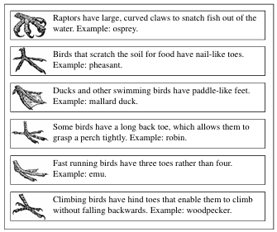
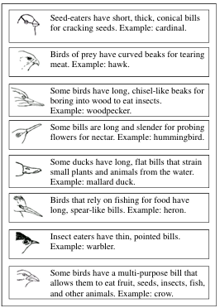

Birds respiratory system.
The avian respiratory system exchanges oxygen and carbon dioxide between the gas and the blood utilizing a relatively small, rigid, flow-through lung, and a system of air sacs that act as bellows to move the gas through the lung.
