SPELEOLOGY. Can staying in a cave cure? Will the peculiarities found inside it allow us to enjoy better health? In this brief article, without exhaustively covering the topic, I will try to outline the answers to these questions.
For ages, the benefits of cave formations have been used to assist in limb injuries. Calcareous formations, in particular, were of great interest, as they were finely ground, gently soaked, tightly applied to the broken area, and bandaged. This created plaster with healing properties extracted from calcite powder. The first such finds and information about similar "operations" were discovered in the Czil Uston cave in India, where under a thin layer on one of the columns, an Indian symbol of the swastika and a faded inscription from the 17th century were found. For the interested, this cave is open for tours.
Rheumatism, on the other hand, is quite a common civilization disease. In the early 19th century, the first studies of this kind were already conducted using underground thermal springs, found in many caves in southern Europe. The results were surprising. It turned out that bathing in these waters brought significant relief and increased health among patients. In Istria, in what is now Croatia, during World War II, gold mining was resumed in a mine founded in Roman times. Miners suffering from rheumatic ailments almost completely healed from this burdening affliction. Thorough scientific studies concluded that the high temperature (over 40 degrees Celsius) and the radiation from the mines containing the radium element were the main therapeutic factors.
The water itself found in cave undergrounds has healing properties and is taken orally. For example, in the Hungarian Tavas Barlang cave (barlang in Hungarian means cave), near the large city of Miskolc, there is an underground lake with a very high content of mineral salts. Patients under the care of this cave sanatorium drink its water, which has a temperature close to thirty degrees Celsius. Medically confirmed effects of the waters have a beneficial influence on the proper development of blood vessels and heart function.
Not only water but also the substrate has many health properties. Studies have been conducted in many caves around the world, representing every "type" of cave environment, yet the result was everywhere the same, positive. It turns out that the clay lying on the cave floor and the limestone milk occurring in karst caves contain strains of bacteria significantly accelerating wound healing. Moreover, it was found that wounds inside caves heal much faster than on the surface, even with the use of dressings, disinfectants, and even advanced antibiotics...
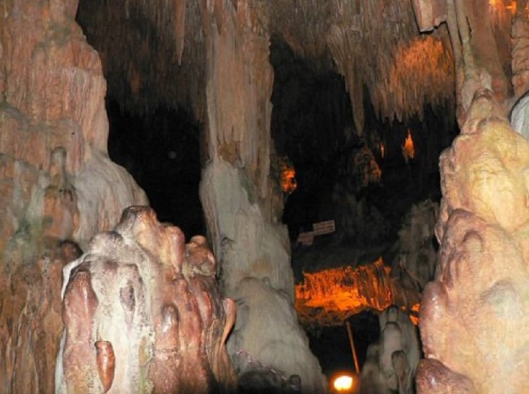
There are serious medical mistakes, and it turns out that staying in caves also has its side effects. The American physician John Croghan, in 1839, bought the right to exploit the longest cave system, the Mammoth Cave, and established his sanatorium there. At that time, there was an epidemic of tuberculosis, so he believed that isolating patients from external factors would bring relief. However, after some time, the mortality rate of customers increased so much that the experiment had to be terminated. Moreover, the initiator himself fell victim to his own venture. Today's medicine has advanced to such an extent in understanding human diseases that we know that high humidity coupled with low temperature prevailing in the Mammoth Cave is highly contraindicated for tuberculosis patients.

In the next episode, we will focus on the impact of staying in caves on the psycho-physical abilities of those who inhabit them.

