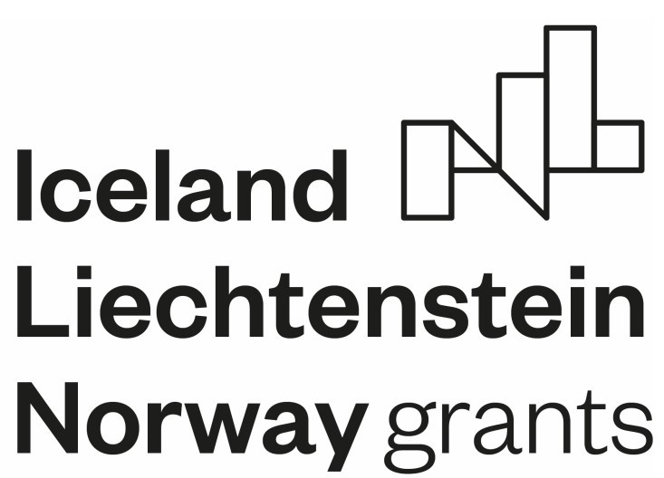 Traditional sweets and desserts:

Skalický trdelník, slices of traditional pastry from the Slovak town of Skalica, ready to serve: note the hollow interior formed during baking on a cylindrical spit.

Sweets are usually prepared during Christmas, but also throughout the year; traditional Slovak sweets are baked at home and are less commonly available in stores.

* Laskonky: fluffy pastry with nuts and cream filling
* Mačacie oči
* Trotle: 2 layers resembling tart cookies with chocolate filling
* Vajcový koňak
* Medovníčky
* Medvedie labky
* Trdelník (Skalický trdelník), traditional pastry baked on a rotating spit over an open fire
* Haboše
* Čeregi
* Makové pupáky

Dietary habits

Traditionally, the main meal of the day is lunch, eaten around noon. However, changes in work patterns have altered this in recent decades, and it's now not uncommon for many Slovaks to have their main meal in the evening. In offices and some large (including international) companies, there is typically a lunch break around midday. Lunch in Slovakia usually consists of soup and a main course. It's a custom in Slovakia to bring a bottle of wine or other alcohol as a gift when invited to someone's home.

