Mountain trees.
Unlike animals, which can descend to lower mountainous regions for the winter, trees must be well adapted to survive at the same altitude all year round. Thanks to their needles, coniferous trees better withstand frost and the weight of snow.
On every level.
Lower parts of the mountains are covered with beech and pine forests, with a predominance of Scots pine and black pine. At higher altitudes, spruce and common fir join them. Larches and dwarf mountain pines are adapted to steep slopes and rocky areas.

Spruce or fir?
To distinguish between spruce and fir, take a close look at the needles. Spruce needles are pointed, slightly prickly, entirely green, and evenly distributed around the stem. Common fir, on the other hand, has flattened needles with rounded tips and a slight indentation in the middle. Fir needles grow in two parallel rows on both sides of the twig.
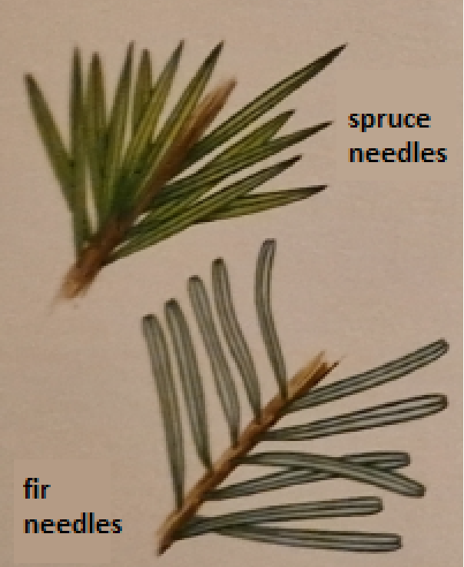

Pine needles.
Take a close look at the pine needle: if they grow in pairs from the stem, it's either a Scots pine, black pine, or mountain pine. If there are five of them, they are larch needles.
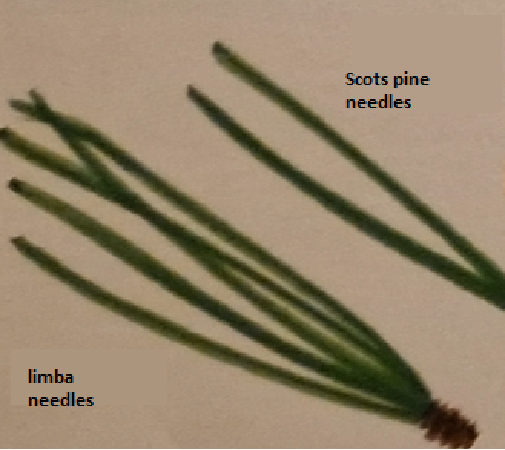

Different sizes.
Spruce, common fir, and larch are the largest coniferous trees. Their height can exceed 40 meters. Shorter ones are Scots pine and black pine, reaching heights of up to 30 meters, followed by larch, which does not exceed 25 meters. Due to harsher living conditions, mountain pine grows up to 3.5 meters.
Take a closer look at the cones.
The position and shape of cones are valuable clues in identifying coniferous trees. Fir, larch, larch, common pine, and mountain pine have cones pointing upwards, while spruce cones hang downwards. Mountain pine cones have flattened scales, somewhat resembling hooks. Spruce and fir cones are elongated and pointed at the end.
Eccentric.
Larch has soft, non-prickly needles. Similar to deciduous trees, they change color in autumn and fall off. Larch isn't afraid of cold and can even grow at altitudes of up to 2500 meters.
