Mountain lakes.
Mountain lakes are natural reservoirs formed in depressions left by glaciers. They vary in size and elevation above sea level.
The largest.
The largest lakes are located on the outskirts of major mountain ranges. Some lakes in the Alps are so large that they are referred to as inland seas. However, they are filled with freshwater. The largest ones include Lake Geneva, 72 km in length, Lake Constance, 64 km in length, and Lake Bourget, 18 km in length. These lakes are very rich in animal life forms resembling those found in ponds.
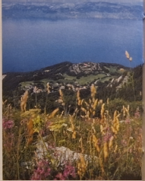
Green lakes.
Lakes situated at elevations from 1500 to 2000 m remain frozen for 6 to 8 months a year. Vegetation growing along their shores makes them somewhat resemble ponds. They contain a lot of organic matter, which gives them a green color. The fish living in them are the same species that inhabit the upper reaches of rivers, such as trout, European bullhead, and minnow. Another species specific to cold lakes, the Arctic char, also joins them.
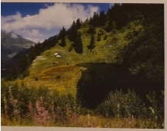
Blue lakes.
At an elevation of 2400 m, the temperature drops even further in the summer. The water temperature does not exceed 9°C. The lake remains frozen for 9 months of the year. Almost no vegetation grows there anymore. Only the brook trout and Arctic char are able to survive in these conditions. The lake's waters are crystal clear.
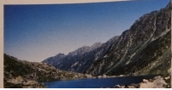

White lakes.
Above 2500 m, the climatic conditions become very harsh for 10 months of the year. There is frost, and the ice cover is quite thick, reaching up to 2 m. There are practically no life forms, neither animal nor plant, found there anymore. If the lake waters are not frozen, they have a whitish color.
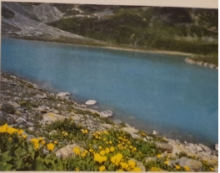

Peat bogs.
Retreating glaciers left behind depressions where water has no outlet. It's somewhat trapped there for about 10,000 years. Some peatlands are already completely overgrown, while others still have a real lake in the middle surrounded by vegetation.
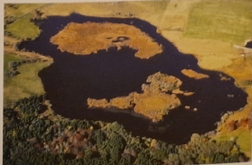

Crater lakes.
In the mountains of Auvergne, one of the geographical regions of France, there are extraordinary original lakes occupying the former craters of volcanoes. They are the result of a gigantic explosion caused by the collision of scattered lava with surface waters. As a result, a large crater is rapidly formed, which is subsequently filled with water. The deepest of the crater lakes, Lake Pavin, reaches a depth of 90 meters.

