Goats
Capra is a genus of mammals, the goats, comprising ten species, including the markhor and several species known as ibexes. The domestic goat (Capra hircus) is a domesticated species derived from the bezoar ibex (Capra aegagrus aegagrus). Evidence of goat domestication dates back more than 8,500 years.
Wild goats are animals of mountain habitats. They are very agile and hardy, able to climb on bare rock and survive on sparse vegetation. They can be distinguished from the genus Ovis, which includes sheep, by the presence of scent glands close to the feet, in the groin, and in front of the eyes, and the absence of other facial glands, and by the presence of a beard in some specimens, and of hairless calluses on the knees of the forelegs.
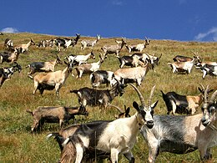

The Alpine ibex (Capra ibex), which is also known as the steinbock, is a species of goat that lives in the Alps of Europe. It is one of ten species in the genus Capra and its closest living relative is the Iberian ibex. The Alpine ibex is a sexually dimorphic species; males are larger and carry longer horns than females. Its coat is brownish-grey. Alpine ibexes tend to live in steep, rough terrain and open alpine meadows. They can be found at elevations as high as 3,300 m (10,800 ft) and their sharp hooves allow them to scale their mountainous habitat.
Alpine ibexes primarily feed on grass and are active throughout the year. Although they are social animals, adult males and females segregate for most of the year, coming together only to mate. During the breeding season, males use their long horns to fight for access to females. Ibexes have few predators but may succumb to parasites and diseases.
y the 19th century, the Alpine Ibex had been extirpated from most of its range and it went through a population bottleneck of fewer than 100 individuals during its near-extinction event, leading to very low genetic diversity across populations. The species has been successfully reintroduced to parts of its historical range. All individuals living today descend from the stock in Gran Paradiso National Park, Italy. As of 2020, the IUCN lists the species as being of least concern.

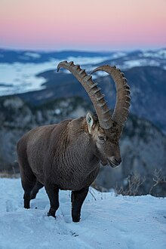

Rupicapra is a genus of goat-antelope called the chamois. They belong to the bovine family of hoofed mammals, the Bovidae.
The Apennine chamois (Rupicapra pyrenaica ornata)[2] is a subspecies of the Pyrenean chamois, a goat-like mammal found in the mountains of Europe. Both male and female have hook-shaped horns that slightly curl backwards and grow little by little each year, never falling off. Their coats are light brown in the summer and darker in the winter, with a light colored mark on the throat. There are also two darker bands on their flanks.
