

A tree as a house

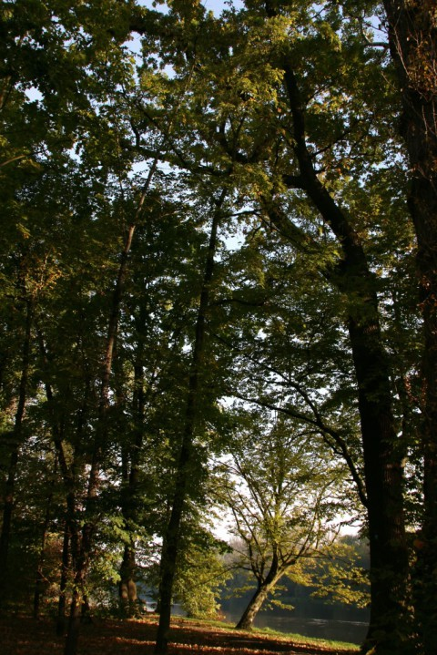

Examining each tree, we can usually distinguish its basic elements: roots, trunk, crown - which consists of a tangle of branches, twigs, leaves, flowers, and fruits. Practically every one of these elements can be utilized by animals as a temporary shelter or as a year-round or multi-year residence.

Let's take a look at who lives among the trees. We'll start with the roots, which in old trees can create powerful root systems, thus providing a convenient shelter for rodents, such as voles or mice. Moreover, besides living burrows with nests, these rodents create pantries in tree roots where they store seeds for the winter. Amphibians and reptiles also seek shelters among the roots, using them as a place for winter rest.



The trunk growing above the roots can have two types of inhabitants - those living just under the bark or on it, and those hiding inside the trunk, for example, in hollows. On the surface of the bark (mainly on linden trees), we can find whole clusters of sunbathing flat bugs. On the bark, as well as underneath it, we can encounter ants wandering aimlessly or instinctively following one another along the same marching route. Ant colonies established under the tree bark provide them with excellent shelter away from the sight of predators. Under the bark, we can also find bark beetles, which feed on the living tissues of the tree and dig tunnels within it, often creating complex labyrinths. Bats also find shelter in the bends and cracks of the bark, although they also hide in hollows. Woodpeckers are, of course, experts in hollows, and the holes they carve are often occupied by other animals, such as squirrels or tits. Larger hollows are inhabited by owls, such as the tawny owl. Sometimes, the space of the hollows is occupied by wild bee swarms.

Bird inhabitants most often utilize the dense foliage in the crowns of trees. Here, far from predators and people, they build nests and raise their young. Individual leaves can also serve as shelter. How? Properly formed by insects, such as leaf-rolling weevils, leaf blades rolled into a tube provide a safe place where the female lays eggs and where larvae develop. Dead trees also serve as shelters for many species of living organisms, but that's another story.

