Leaves

What is a Leaf?

Leaves are one of the three organs of a plant. The most important job of a leaf is to make food for the plant. Leaves are the main (but not only) organ responsible for turning sunlight into food. Leaves have different sizes, shapes, and textures, depending on what is most useful in their habitat. The green pigment found in most leaves absorbs sunlight, which is one of the important ingredients in the food-making process.

Harvesting Sunlight

Leaves are the main (but not only) organ responsible for turning sunlight into food. The green pigment found in most leaves absorbs sunlight, which is one of the important ingredients in the food-making process. This process is called photosynthesis.

During photosynthesis, chlorophyll captures the energy of sunlight. The plant combines energy from sunlight, carbon dioxide from air, and water and nutrients absorbed by the roots to make glucose (sugar). Oxygen is produced during photosynthesis and is used by most living things (including people).

Exchanging Gasses

Leaves have a very important part that is too small for us to see with our eyes. Stomas! To see stomas on a leaf, we need to use a microscope.

Stomas are small holes on the surface of the leaf that allow gasses into and out of the plant. Each stoma contains two guard cells. Like guards of a castle, the guard cells protect the stoma, opening the stoma when it is time to exchange gasses with the air, and closing the stoma when the plant needs to conserve resources. Without stomas, plants could not get the gasses they use in photosynthesis to make their own food.

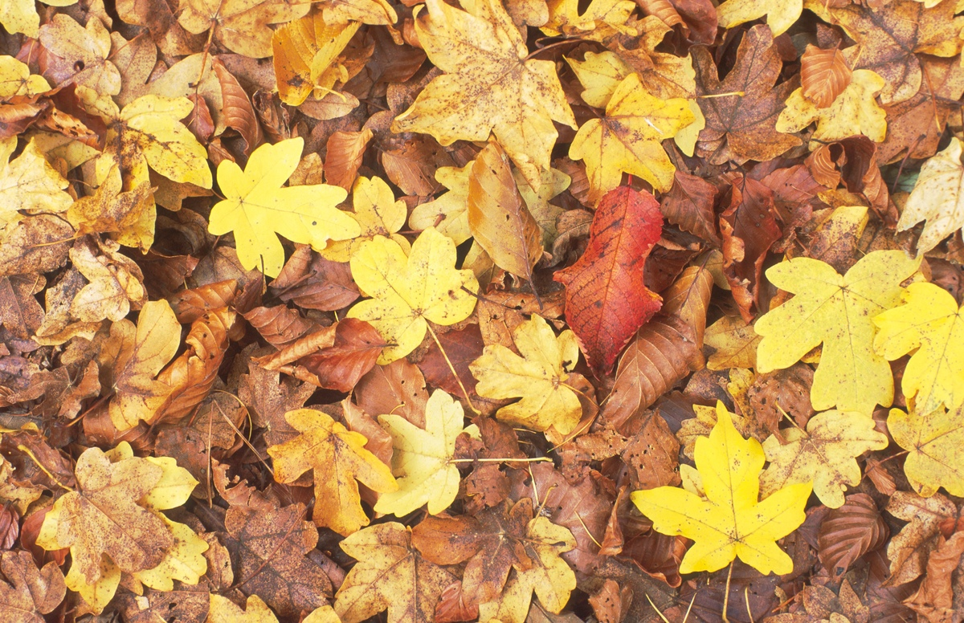

Disappearing Green

Different natural chemicals within trees produce different colours of leaves. Chlorophyll is the chemical that produces a green colour, and it happens that photosynthesis (the process of turning sunlight into energy, which is key to tree growth) is most efficiently processed with green leaves. It’s the same reason that most growing plants are green. Trees intentionally fill their leaves with chlorophyll in order to generate as much energy as possible during the summer months.

By the time autumn comes around, trees have been busy generating and storing energy from sunlight for several months. In many ways, they have been preparing all year for the coming winter by storing energy and sugars to tide them over the coming winter. With temperatures falling in autumn, production of chlorophyll stops and the levels of this chemical within leaves reduces. In turn, this lets other chemicals within the leaves come to the fore.

As chlorophyll reduces, it leaves an abundance of carotenes which are yellow. This yellow has been in the leaves all year, but superseded by the green – in autumn, it finally gets a chance to show itself. If the temperature stays above freezing, anthocyanins are produced which bring about reds and pinks. Also, the drier and sunnier the autumn, the more anthocyanins are produced, and the more red the leaves will be. This process happens slowly over the autumn, and not uniformly throughout the tree, so we see trees with a broad mix of greens, yellow and reds that is constantly changing.

Dispensing With Leaves

In the spring, a layer of cells called the abscission layer is formed where a leaf grows out from a branch. During the growing season, the tree hormones and chemicals are fairly steady, and this layer allows energy from the leaves to be passed into the branch and trunk to be stored. In autumn, with the cooler temperatures and shorter days, the production of one hormone called auxin reduces. This in turn puts a strain on the abscission layer and causes the bond between leaf and branch to weaken. Eventually, the strength of the join is weakened enough that the wind will blow the leaf away.

There are several reasons why deciduous trees lose their leaves:

It means the tree spends less energy through the harsh winter

It conserves moisture within the trunk and keeps it from drying out

It allows wind to blow through the branches, putting less strain on the tree – a serious concern in winter storms and gales