The population.
The chart shows the population of individual voivodeships in the year 2017. Examine it carefully and color the voivodeships on the map according to the legend. Then complete the sentence at the bottom of the page.
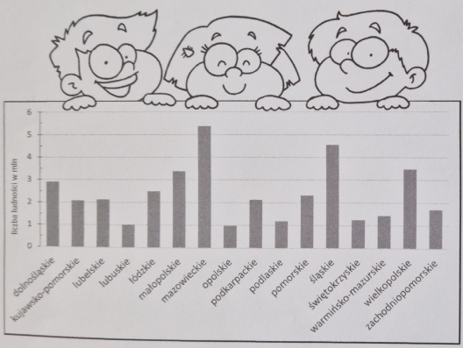

Legend:
Population above 4 million color red.
Population from 2 to 4 million color orange.
Population below 2 million color yellow.
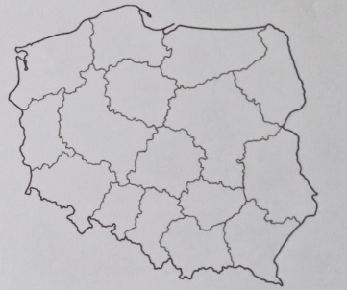

The fewest people live in the Opole Voivodeship, and the most in the Voivodeship………………………………………………………………………………………….

