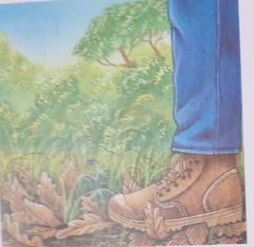
Everything that falls and mixes with the soil, we call humus

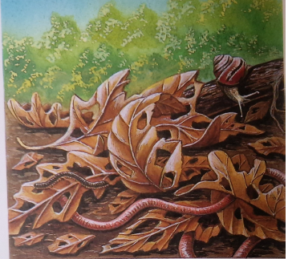
Earthworms shred leaves.

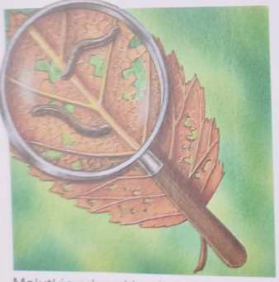
Tiny bugs eat the inside of the leaf.

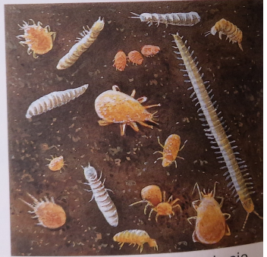
Tiny bugs eat the inside of the leaf.

