Previous lessons were dedicated to discussing running and jumping events. The next track and field events worth exploring are the javelin throw, discus throw, hammer throw, and shot put.

Slide 1

Javelin Throw - One of the technical events in athletics, which involves throwing a javelin as far as possible.

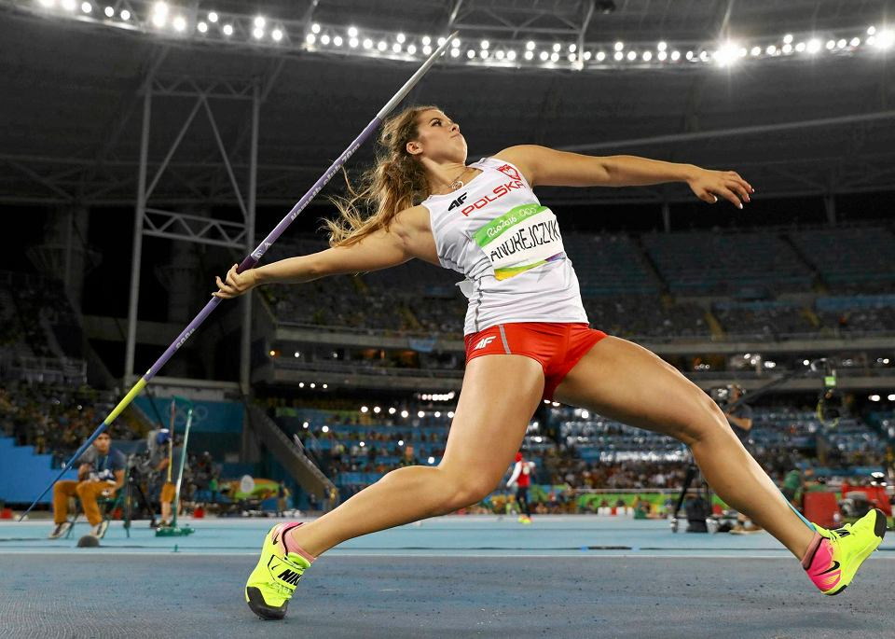

Photo <https://www.sport.pl/igrzyska-olimpijskie/7,154863,20568328,rio-2016-rzut-oszczepem-andrejczyk-po-finale-to-byla-zenada.html>

Slide 2

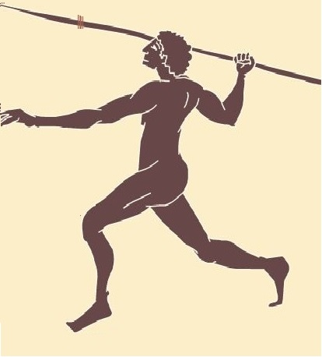

http://igrzyskaolimpijskie.opx.pl/2.htm

The javelin was known in ancient times and had two variants. Javelin throwers would aim at a target and throw for distance using javelins made from olive wood. Throws were allowed with one hand or both hands.

Around 1780, the Finns adopted this discipline, and the javelin became a symbol of independence for them. They made their equipment from hickory wood.

In 1859, in Athens, javelin throwing competitions were held for distance and accuracy to celebrate the revival of the Olympic Games. At that time, athletes threw from a standing position, resulting in much shorter distances compared to today. It wasn't until 1885 that athletes started using a run-up to improve their results. However, the technique differed significantly from the current one, as it underwent numerous modifications over the years, just like the javelin itself.

**Slide 3 (Olympic Flag)**

The javelin throw reappeared in the modern Olympic Games in 1908, with only men competing in this event. It wasn't until 24 years later, in Los Angeles, that women also joined the competition. The javelin throw was included in the European Championships in 1934 (men) and 1938 (women), and in the Polish Championships in 1920 (men) and 1923 (women).

**Slide 4**

Javelin throwing competitions are held at an athletics stadium, specifically in an area called the javelin sector. It begins with the runway (maximum length of 36.5 meters and 4 meters wide) and ends with an 8-meter radius arc. The throwing sector is marked with white lines and is a segment of a circle with a 29-degree angle. (sample diagram of the javelin sector)

The athlete performs the javelin throw with a metal spear consisting of a tip, shaft, and a binding that serves as the center of gravity (drawing taken from a random presentation - it's recommended that a graphic designer creates an original illustration).

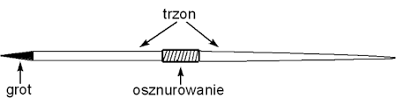

The weight of the javelin varies depending on the age and gender of the athletes. During international competitions, the following javelin specifications are used:

a) Women - javelin length 220-230 cm and weight 600g

b) Men - javelin length 260-270 cm and weight 800g

The athlete performing the throw must hold the javelin by the binding, and the throw must land within the designated sector. If the javelin lands outside the lines or the athlete steps over the runway line, the throw is considered a foul. For a throw to be measured, the javelin must leave a mark where it lands and must land within the designated sector.

Slide 6

The javelin throw consists of 6 phases:

1. Initial phase - The athlete stands facing the direction of the throw with the throwing arm relaxed and holding the javelin above the head. An important element of this phase is the proper grip of the javelin and concentration.

2. Approach phase - This phase consists of the acceleration phase (the athlete performs a relaxed run, gradually increasing speed) and the delivery phase (javelin withdrawal, transition to the crossover step, and javelin throw).

3. Delivery position - In this position, the athlete assumes a backward-leaning, twisted stance, with the back leg bent and the lead leg extended forward. The arm holding the javelin is fully extended away from the leg.

4. Throwing phase - This phase begins when the athlete plants the lead foot firmly and straightens the back leg while rotating it outward. The hip and torso move forward and upward (hips and shoulders aligned in the same plane). The athlete's position resembles a taut bow. The throw is executed simultaneously by the chest, shoulder, and arm, which holds the javelin high, guiding it over the head and forward for the throw.

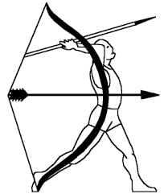

<https://sp13.piotrkow.pl/content/artykuly/files/w-f/VIIIABC_01_05_06.pdf>

1. Balance maintenance phase - the lead leg transitions forward through a hop, followed by the athlete performing several braking hops.

2. Final phase - Exiting the runway without crossing the end line.

Slide 7

Task

An alternative to javelin throwing in school settings can be shot put.

Watch the video demonstrating the throwing technique and then try to perform the exercises shown.

https://www.youtube.com/watch?v=UwDQ2gmrYoQ&t=9s

Slide 8

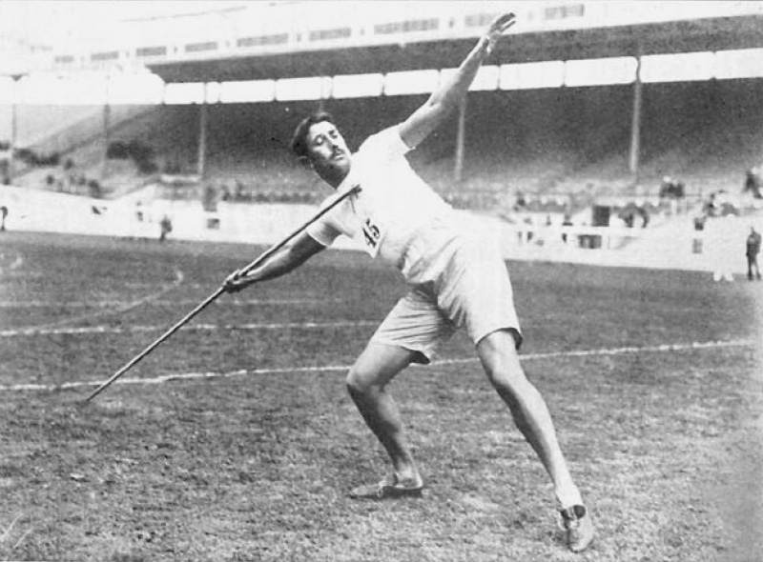

The first Olympic champion in javelin throw was Eric Lemming (https://pl.wikipedia.org/wiki/Rzut_oszczepem).

The men's javelin throw record belongs to Jan Železný, who threw the javelin 98.48 meters in 1996. The women's record stands at 72.28 meters, set by Barbora Špotáková in 2008.

On the Polish arena, the best results were achieved by Maria Andrejczyk, who threw the javelin 71.40 meters in 2021, and Marcin Krukowski, who threw the javelin 89.55 meters in the same year.

Slide 9

Discus throw is a technical athletics event involving throwing a discus by hand (using arm strength) for the farthest distance possible.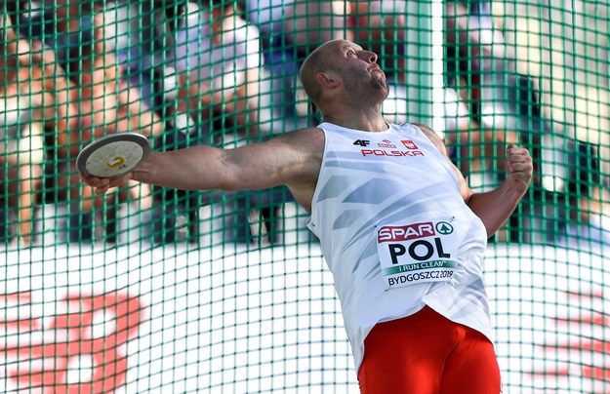

**https://www.rmf24.pl/sport/news-historyczne-zwyciestwo-polskich-lekkoatletow,nId,3143620#crp_state=1**

**Slide 10**

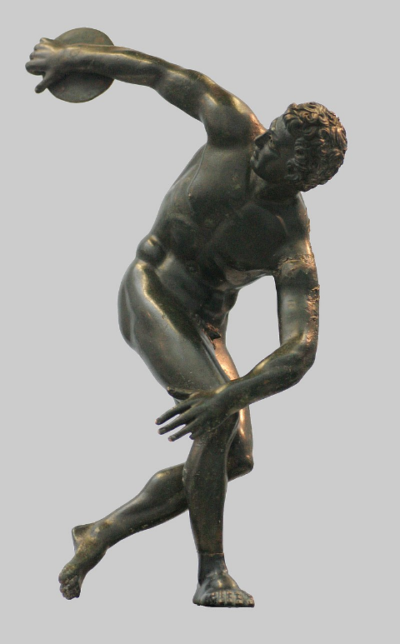

<https://pl.wikipedia.org/wiki/Rzut_dyskiem>

In Greek mythology, we can read that one of the first discus throwers was Perseus, and this competition was part of the pentathlon. The discus throw was then performed from a stationary position with both the right and left hands, and the sum of distances determined the winner. The winner received a discus made of valuable iron as a prize.

In 1912, during the Olympics, a two-handed discus throw contest was held. The winner was Finnish discus thrower Armas Rudolf Taipale, who threw a distance of 82.86 meters (44.68 + 38.18 m).

Slide 11

Men's discus throw has been an Olympic discipline since 1896. The first gold medalist, with a throw of 29.15 meters, was American Robert Garrett.

Women competed in this event at the 1928 Olympics. Polish athlete Halina Konopacka emerged as the top performer, throwing the discus 39.62 meters and thus becoming the first female gold medalist in history.

Slide 12

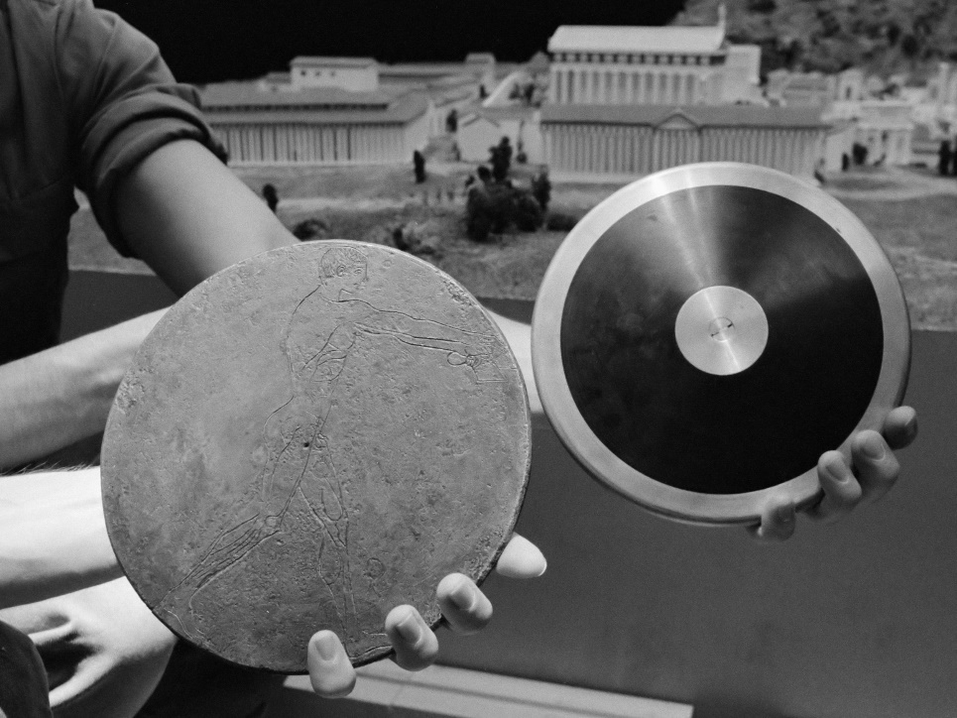

Photo: Ancient and modern discus (https://en.wikipedia.org/wiki/Discus_throw)

The athletic discus is constructed of a wooden disc with a metal rim around it. The men's discus has a diameter of 219-221 millimeters and weighs 2 kilograms, while the women's discus measures 180-182 millimeters in diameter and weighs 1 kilogram.

Competitions take place in the athletics stadium, with athletes making throws from a circle with a diameter of 2.5 meters. The throwing area is surrounded by a net 4 meters high.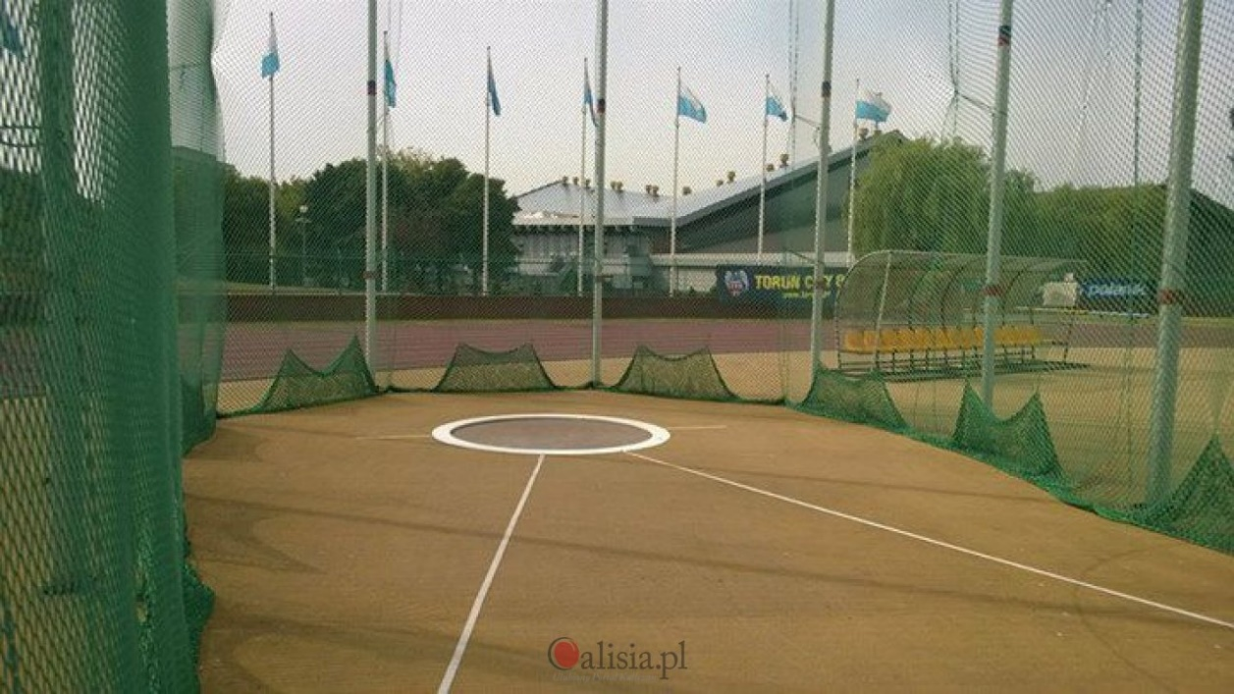

<https://calisia.pl/mlodzi-lekkoatleci-potrzebuja-pomocy-w-budowie-rzutni-do-dysku,17531>

During the throw, the athlete must not cross the circle's rim, and the disc must soar beyond the net.

Slide 13

Discus throw consists of successive phases:

1. Starting position and swings - the athlete stands with their back to the throwing direction, their arms make loose pendulum movements to prepare the muscles for rotation. During the swings, the athlete shifts their body weight from one foot to the other. A crucial element in this phase is how the discus is held and concentration on the movement.

2. Approach phase - begins with the far-reaching of the arm behind the back and shifting the body weight low onto the bent knee. The right leg is positioned around the left leg low to the ground in the direction of the throw. The next step is shifting the leg with a short movement and placing it within the diameter of the circle. The legs lead the movement of the torso, giving the athlete additional force to transition to the release phase.

3. Release position - the body weight rests on the supporting leg, which is on the midfoot at a right angle to the throwing direction. The torso is leaned forward, and the arm with the discus is extended far back over the heel of the trailing leg.

4. Release phase - in this phase, the athlete's foot passes through a turn to rise onto the toes towards the throw. The athlete rotates around the left axis through the foot, hip, and shoulder, then proceeds to release the discus. The correct position causes the discus to rotate, giving it the correct trajectory and flight force.

5. Post-release position - after making the throw, the athlete must maintain a stable position to avoid crossing the boundaries of the throwing area. This is achieved by shifting from one foot to the other and compensating for the body's inclination with arm movements.

Slide 14

The current world records in discus throw belong to Jürgen Schult (74.08m) and Gabriel Reinsch (76.80m). The Polish record holders are Piotr Małachowski (71.84m) and Renata Katewicz (66.18m).

Slide 15

1. Name two variants of javelin throw used in ancient Greece? (Target throw and distance throw)

2. What was the javelin made of in ancient times? (Olive wood)

3. From which year did women start competing in javelin at the Olympic Games? (1934)

4. Provide the javelin parameters for women and men. (Women - javelin length 220-230 cm and weight 600g, Men - javelin length 260-270cm and weight 800g)

5. Name the parts of the javelin. (Point, shaft, binding)

6. What is the best javelin throw result among men and who set it? (Jan Železny 98.48 m)

7. What was the name of the first discus thrower according to Greek mythology? (Perseus)

8. What is the name of the Polish woman who was the first female to win an Olympic medal in discus throw? (Halina Konopacka)

9. Name the phases in the discus throw (starting position and swings, approach phase, release position, release phase, post-release position)

10. Provide the record throws of Piotr Małachowski and Renata Katewicz (Piotr Małachowski 71.84m and Renata Katewicz 66.18m).